Shetkari Shikshan Sanstha’s
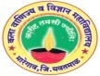
ARTS, COMMERCE & SCIENCE COLLEGE, MAREGAON (ROAD)
Dist. Yavatmal- 445 303 (M.S.) India
(Affiliated to Sant Gadge Baba Amravati University, Amravati)
NAAC Accredited at ‘ B+’ grade with CGPA 2.51

Seminars/conferences/workshops conducted by the institution during 2020-21
One Day e-workshop on ‘Recent Trends in Algebra Career perspectives,

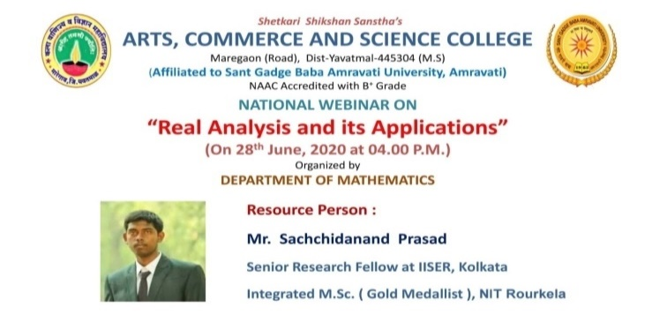
Department of Mathematics has organized this webinar for students of Mathematics to improve their knowledge in Real Analysis and to explore its various applications of real life. The aim of this webinar was to enhance the interest of students in Real Analysis and encourage them to use the lockdown period for developing their habit of learning in an effective way in the COVID-19 pandemic situation.
Resource Persons of the webinar was Mr. Sachchidanand Prasad, Research Scholar (SRF) at IISER, Kolkata, West Bengal, India.
Total participants: 100

International e- conference on Recent Advances in Material Science and Nanotechnology (RAMAN-2021)
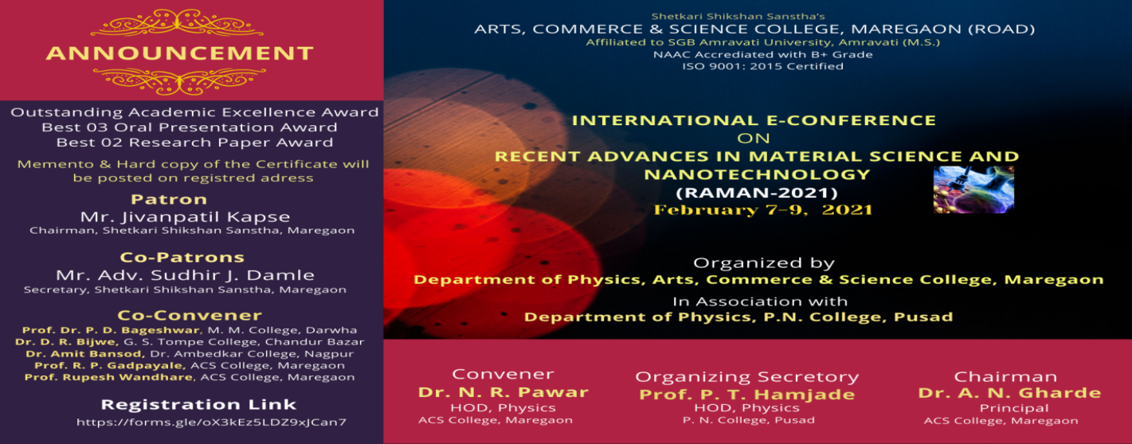
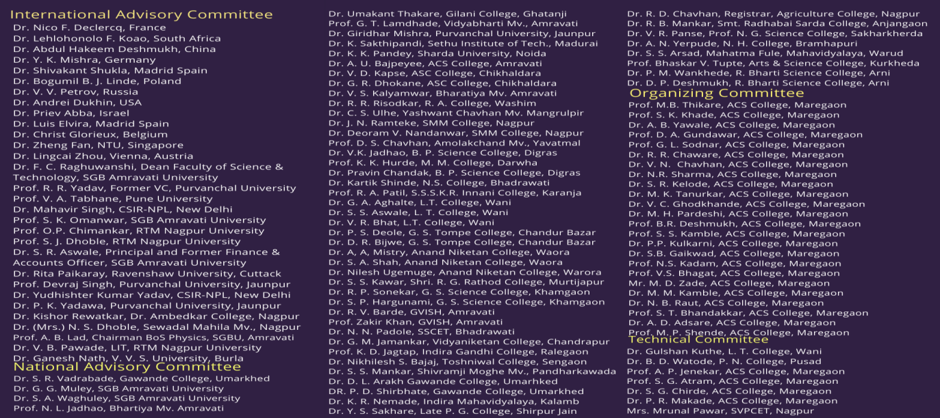
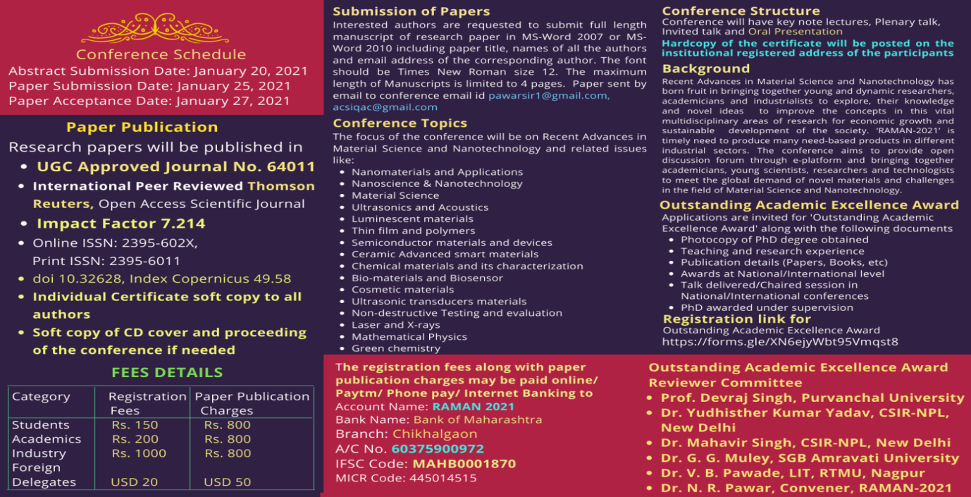
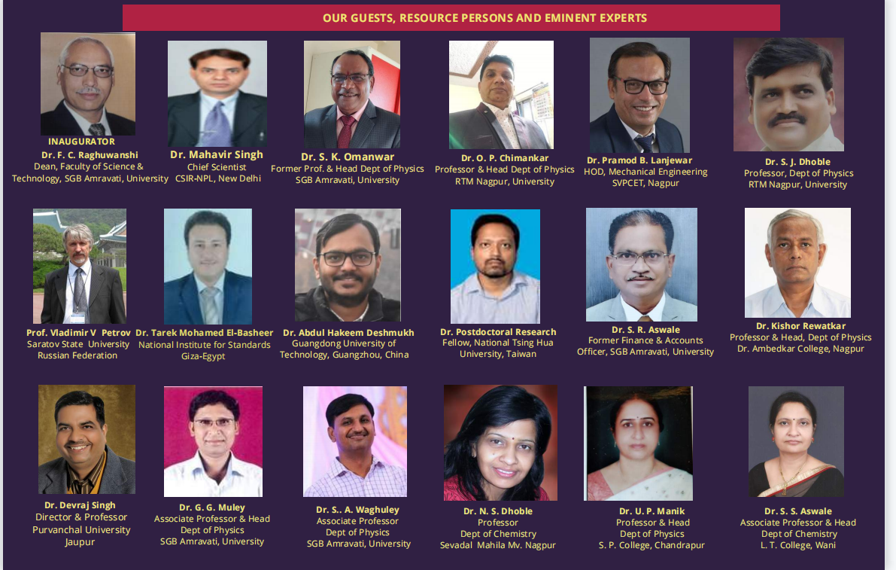
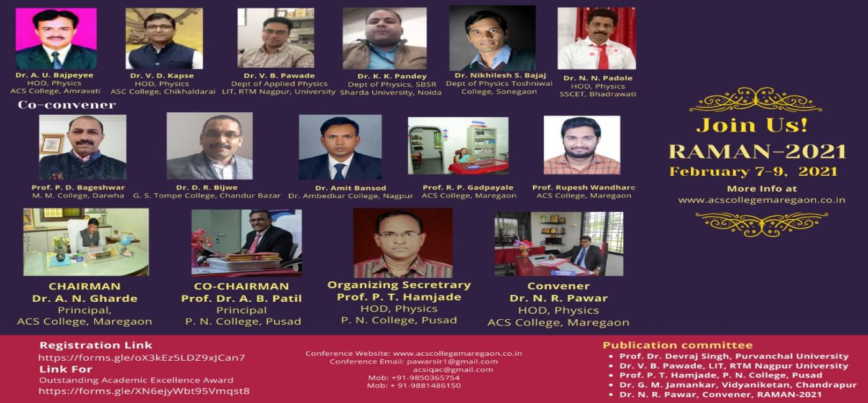
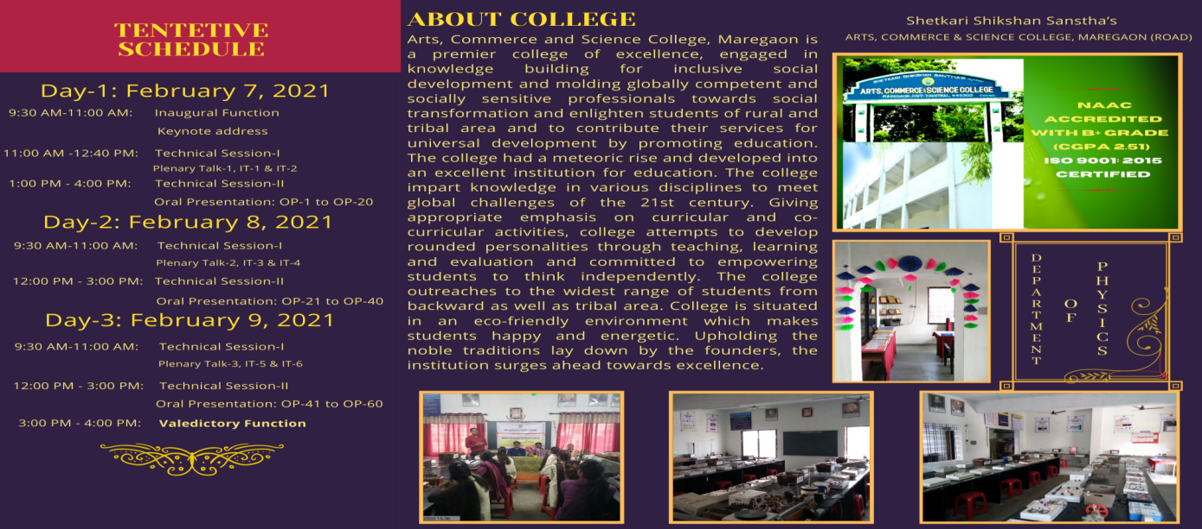

International e-Conference on Recent Advances in Material Science (RAMAN-2021) was organized by the Department of Physics, Arts, Commerce & Science College, Maregaon in association with Department of Physics, Phulsing Naik Mahavidyalaya, Pusad during February 7-9, 2021.
This conference was provides an opportunity on a vibrant and dynamic e-platform to all participants for exchange information and new advancements of the concerning fields among scientists, engineers, industrialists, researchers and academicians. The conference was focus mainly on Material Science and potential applications of Nanotechnology in everyday life for the betterment of human society. This conference was also provides an unique opportunity for teachers, educators, experts and scholars of higher education from all over the world to convene and share novel ideas on the field and trends in higher education development.
The Proceedings brought out includes 131 original full length research papers of high standard and 199 abstracts received from various regions of the world. In addition to this one keynote address, 4 plenary talk and 9 invited talks by the experts and 160 papers was displayed for interactive oral presentation and 273 registrations.
The RAMAN-2021 was enjoyable, memorable and productive for the participants. All delegates was benefited substantially from the conference through the presentations of expert speakers and exchanges of ideas with one another.
One Day Workshop on "Awareness about Sexual Harassment"

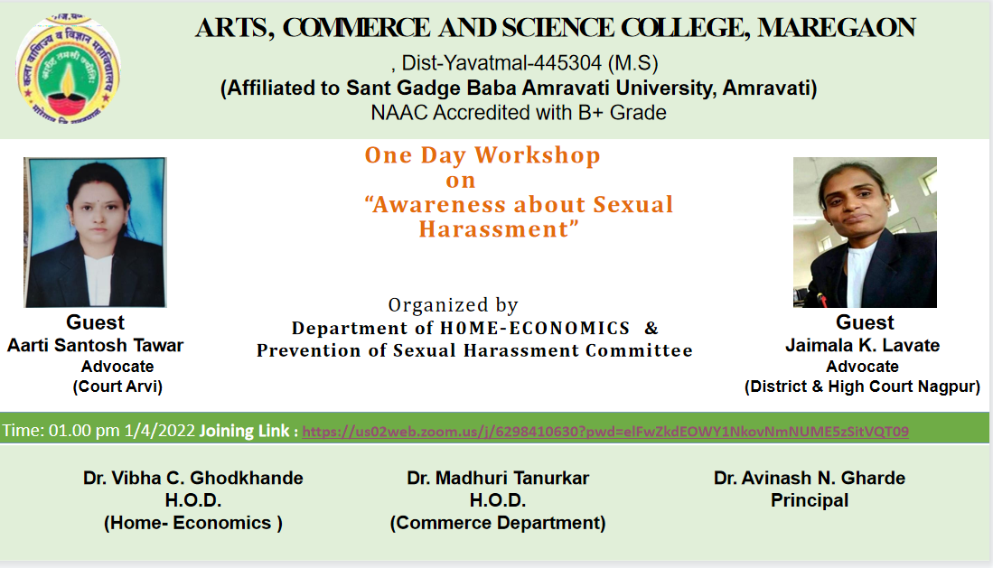
One Day Webinar on " Conservation on Biodiversity, Global Warming & Know your Environment"
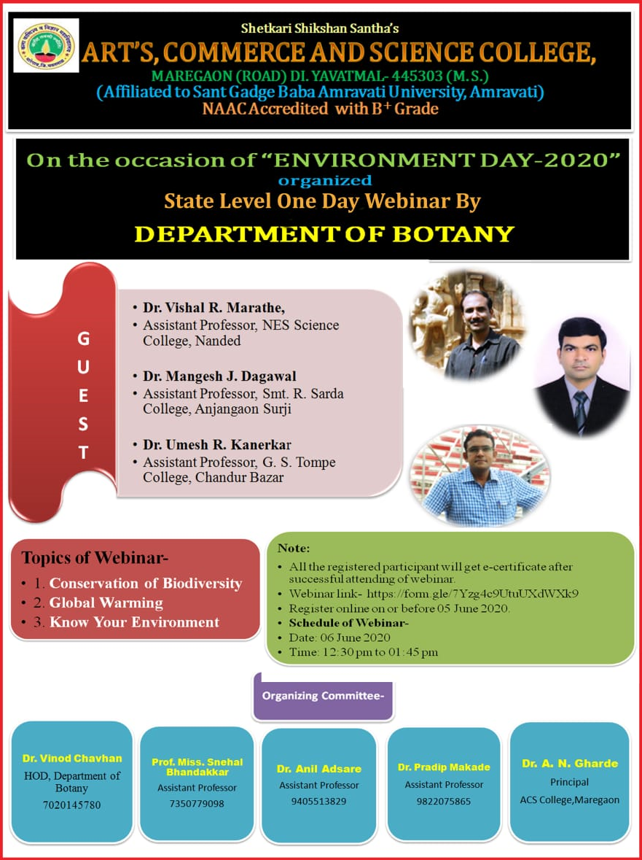
National E-Conference on Impact of Covid-19 on Indian Economy (ICIE-2021)

One day Interdisciplinary National E-Conference organized by department of CommerceArts Commerce & Science College Maregaon on Impact of Covid-19 on Indian Economy. 200 Researcher and academician has responded to the conference and send their paper. Dr. Sandeep Gaikwad Head Department of Commerce and Managemen from Shri Muktanand College Gangapur acted as Resource person in the conference and assisted to the convener for the successful organization of the conference.
While talking Principal Dr. A.N. Garde given good remark about the conference and he satisfied with the content and MOU did between the two colleges. Dr .Syed Azharuddin Head Department of Commerce and Management from Dr. Babasaheb Ambedkar Marathwada University, Aurangabad has given speech on impact of covid on various sector. More than fifty academician given positive remark on the conference.

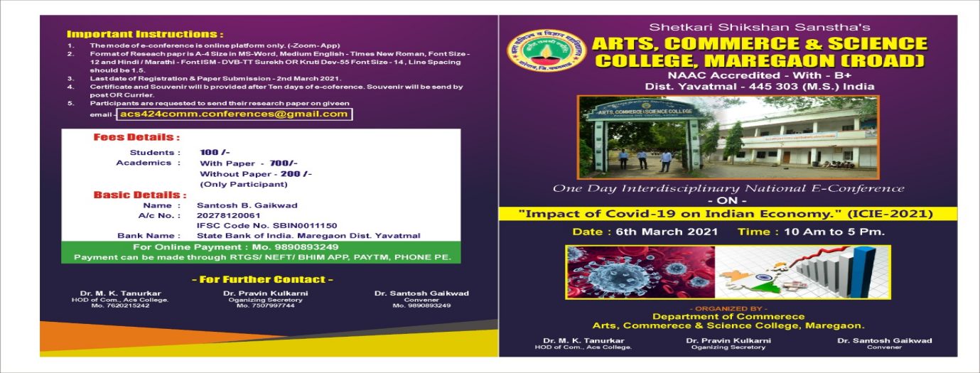
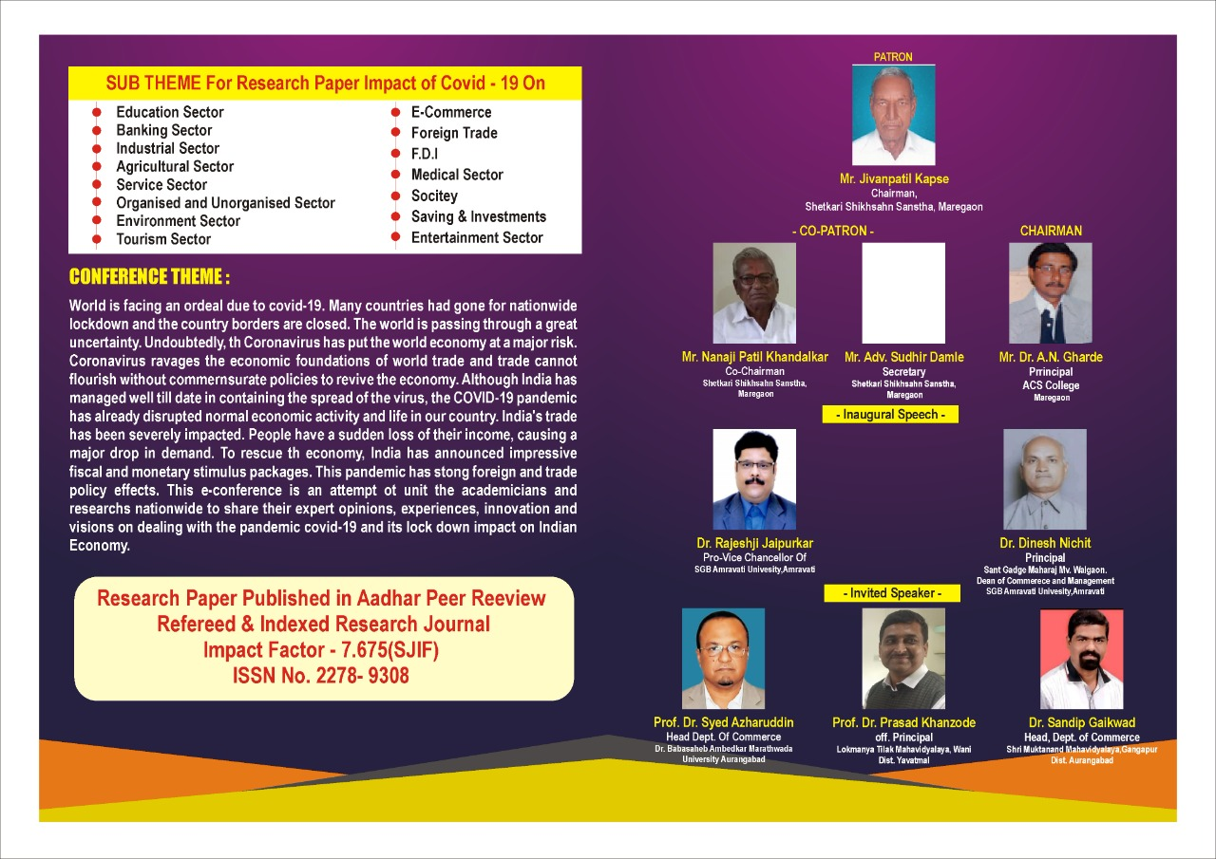
One Day Webinar on GENDER EQUITY on 02 April, 2021
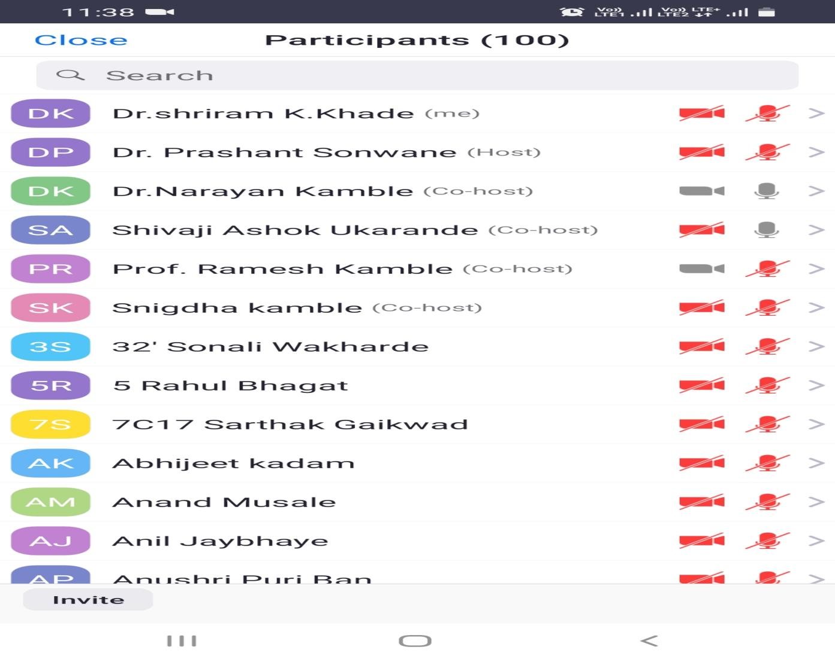
Department of Mathematics in Collaboration with Department of Physics and IQAC have organized a Webinar on “Life of C.V. Raman and his contributions” on the celebration of National Science Day 2021 dated 28 Feb 2021.

On the occasion of National Science Day 2021, we got an opportunity to hear Dr. Agarkar Sir, Prof. And dean, vpm’s academy of international education and research. (Retired professor from TIRF Mumbai.)
It was conducted online on Zoom Platform and live Streamed on YouTube.

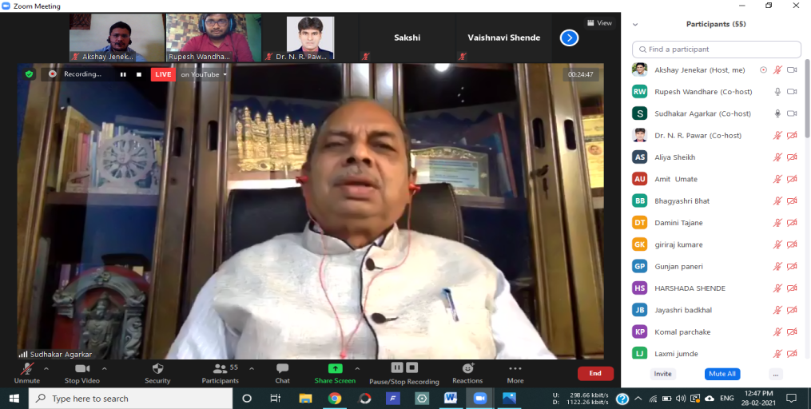
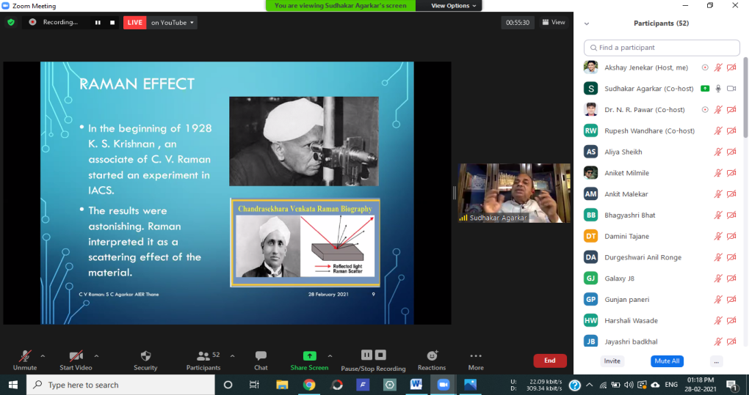
News about the celebration of National Science Day 2020 has been published in Newspaper:
Deshonatti yavtmal live page no. 4 , Date: 04 March 2021
News link: https://deshonnati.digitaledition.in/c/58834131
Sakal newspaper yavatmal today Date: 06 March 2021
News link: http://product.sakaalmedia.com/portal/SM.aspx?ID=306153
Department of Mathematics has organized Webinar on “'Importance of Pi and Life of Albert Einstein' for the celebration of International Pi Day on 14/03/2021.
International Pi Day is celebrated on March 14 around the world because, the numbers in the date i.e. 3, 1, and 4 matches with the first three significant digits of Pi and it also happens to be the Alberts Einstein’s birthday – The perfect Pi co-incidence.
Registration Details: https://docs.google.com/spreadsheets/d/1d8_7ea5jh3Uwd3TOAuQURSlthaKoHJA_tdJ2JWgVYdA/edit?usp=sharing

Resource Person: Dr. Sudhakar Agarkar, Prof. & Head, VPM’s Academy of International Education & Research, Thane, Retired professor from TIRF Mumbai.
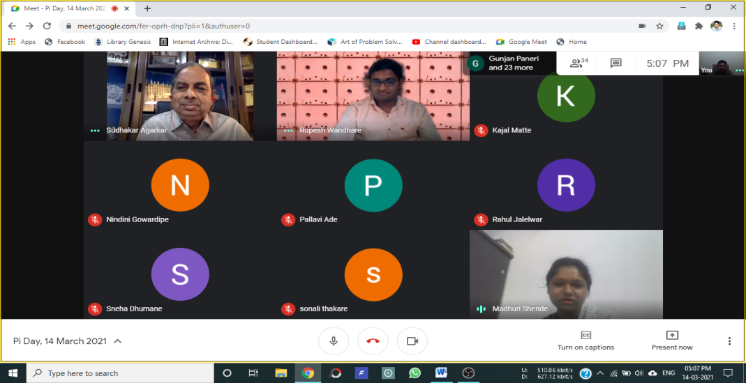
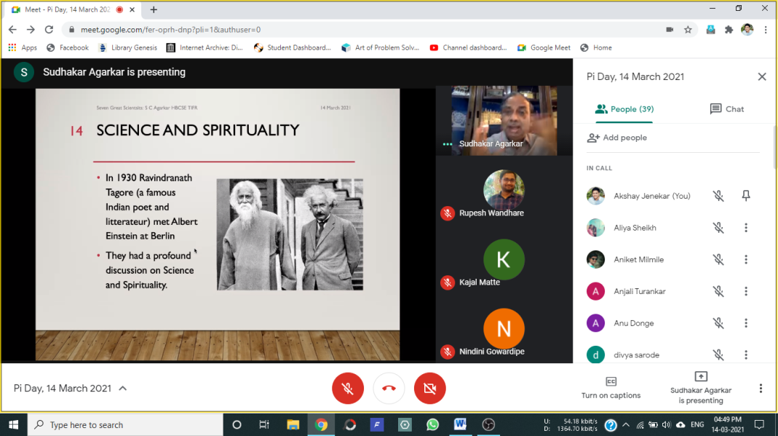

Feedback from students:
https://docs.google.com/spreadsheets/d/19TQEkWkPNoZX584rSalkSh4lZC5LM3BQ9oO1sXXGu4c/edit?usp=sharing

National Webinar Roll of Chemistry to Prevent the Covid-19 on 28 May, 2020
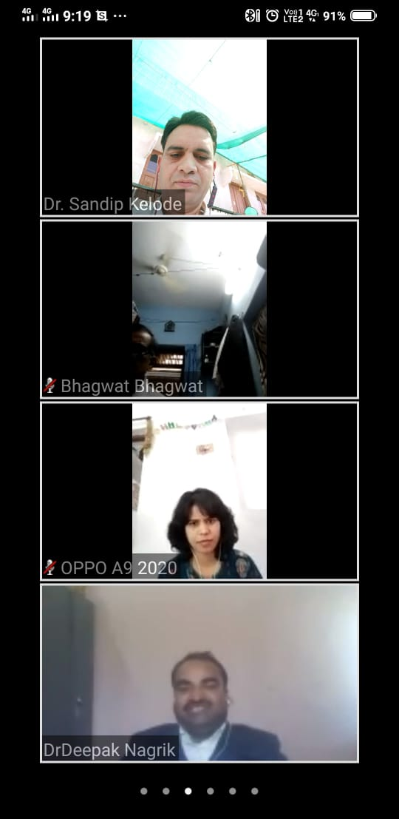
National Webinar on Strategies to crack competitive exams in chemical science and role of nanotechnology to combat climate change on 19 March, 2021
