Shetkari Shikshan Sanstha’s



**ARTS, COMMERCE & SCIENCE COLLEGE, MAREGAON (ROAD)**

Dist. Yavatmal- 445 303 (M.S.) India

(Affiliated to Sant Gadge Baba Amravati University, Amravati)

NAAC Accredited at ‘B+’ grade with CGPA 2.51 (Cycle-I)

**1.1.1:** **The Institution ensures effective curriculum planning and delivery through a well-planned and documented process including Academic calendar and conduct of continuous internal Assessment**

The college adopted following initiatives for curriculum delivery.

• Every department has designed unique and effective teaching methods which are compiled in the form of a manual.

• The institution has provided ample opportunities to integrate technology for improvement in learning.

• The institution has a systematic evaluation method which is strictly adhered to.

• Preparation of 3 sets of question papers per subject, random second valuation, opportunity for revaluation, re-totaling and personal seeing.

• Students are provided with opportunities to acquire additional skills through NSS, cultural center and various forums.

• The scheduling of activities is done systematically and it is reviewed regularly.

• Student representatives are involved in governance.

• Effective and timely feedback is a critical component in the institutional performance.

• Information pertaining to the curricular contents is studied by referring curricula of reputed institutions/universities in India.

• Collecting feedback from employers and alumni, for designing of curriculum.

• All the information gathered are presented in the IQAC meetings for approval.

**Historical Visits**

* **At Manikgad Fort, Gadchandur Year: 2016-17**

**No. of Participated Students**: 67

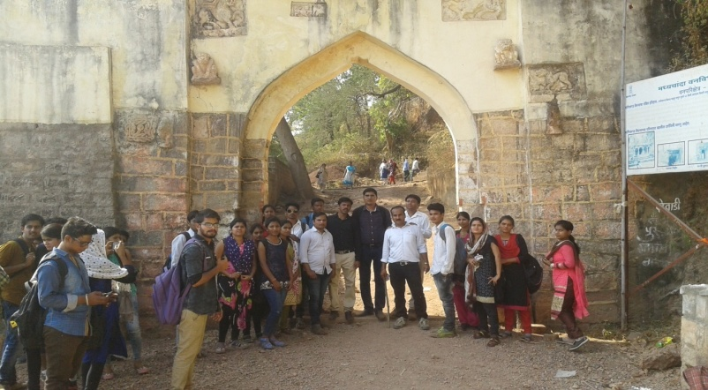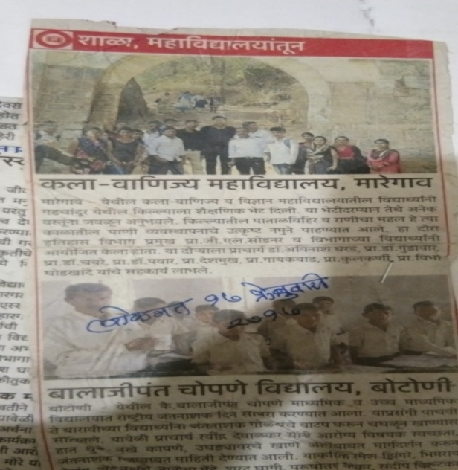

* **Year: 2018-19 (Rajasthan)**

Conducted an educational tour on dated 02 march 2019 to 09 march 2019. The aim of study tour was to visit and study of ancient and medieval architecture places in the cities of Ahmadabad, Udaypur, Jodhapur, Jaisalmer and Jaipur. The entire journey was carried out by train along with **15** students

