Shetkari Shikshan Sanstha’s
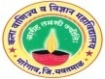
ARTS, COMMERCE & SCIENCE COLLEGE, MAREGAON (ROAD)
Dist. Yavatmal- 445 303 (M.S.) India
(Affiliated to Sant Gadge Baba Amravati University, Amravati)
NAAC Accredited at ‘B+’ grade with CGPA 2.51 (Cycle-I)

1.3.1: Institution integrates crosscutting issues relevant to Professional Ethics, Gender, Human Values, Environment and Sustainability into the Curriculum
College integrates crosscutting issues related to professional ethics, gender, human values, environment and sustainability into the curriculum. Various cells and committees of the college were conducted number curriculum and extra-curriculum activities for girl’s students. The women cell and woman anti-harassment committee organizes woman empowerment program, Laws for woman, women’s day, etc. Major gender issues are focused and addressed through the activities like save girl child campaign, poster competition, etc. The NSS unit of our college organizes various extension activities in college premises and in adopted villages during camp. The vision of the college is to offer general education and cultural improvement to produce students who will be equipped to practice justice, honors and charity in their various vocations of life. The goals and objectives are well articulated and they are duly disseminated to fresher through the college calendar, prospectus, website and induction meetings held at the beginning of each academic session. The college encourages the students to take active part in the cocurricular and extra-curricular activities. Any act against rules and discipline of the college will be considered as indiscipline and that student or a group of students are liable for the disciplinary action decided by the principal and the discipline committee of the college.
- Any act against rules and discipline of the college will be considered as indiscipline and that student or a group of students are liable for the disciplinary action decided by the principal and the discipline committee of the college.
- Compulsory Course Environmental Study for BA-II, BCom-II and BSc-II introduces the necessary concepts about conservation of biodiversity and prevention of pollution
- Organized workshop on Gender equity and on various related issues
- Organized Environmental Study tour for students each year.
- Tree plantation 03 November, 2016
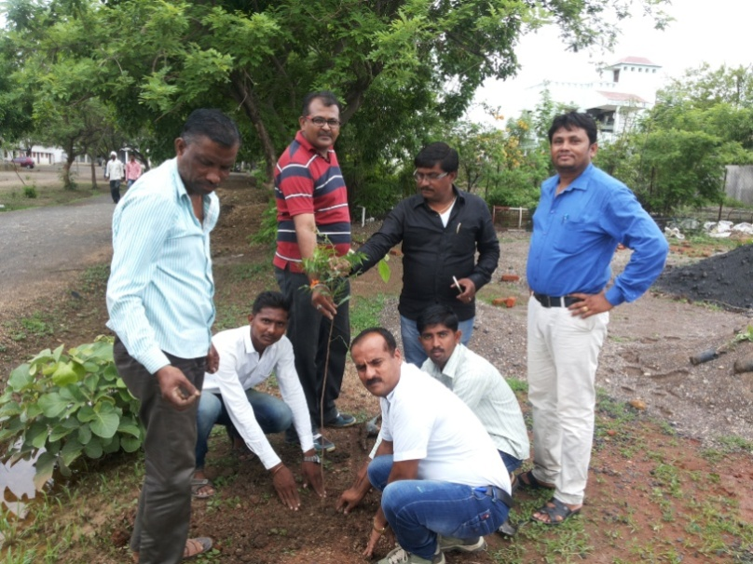
- Arranging water in hanging bottle for birds in summer session on 27 April, 2017
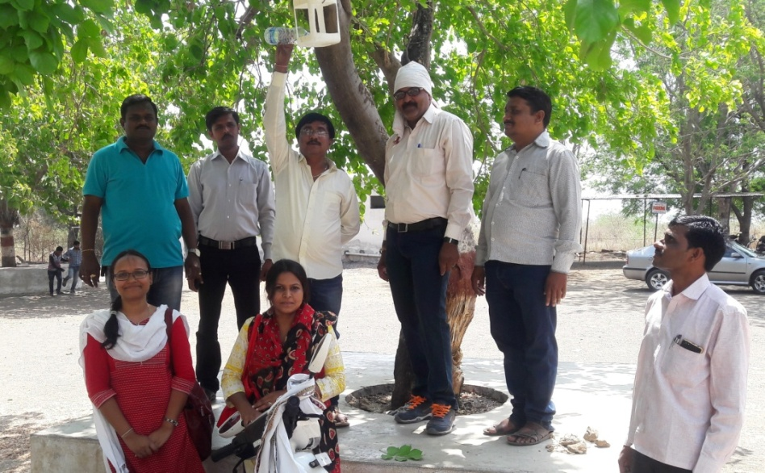

- On the occasion of the “Wild Life Week” Department of Botany is organizing poster competition, guest lecture and video presentation on 01 to 10 October, 2016.
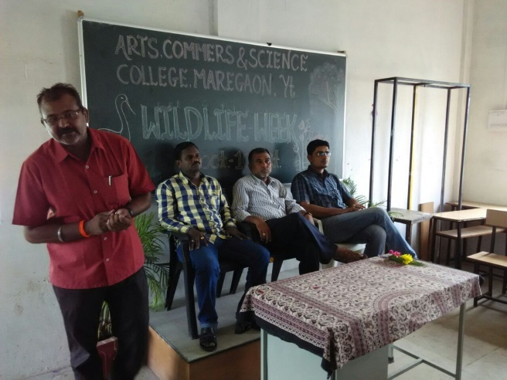

- On the occasion of “Rakshabandhan” The students of the Department are making handmade Rakhi and it’stying to the tree and celebrating the Rakshabandhan.
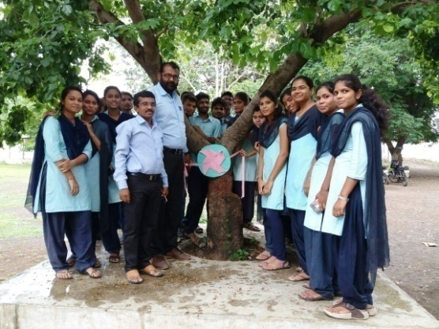

- Tree plantation program organized by on the occasion of Rakshabandhan.
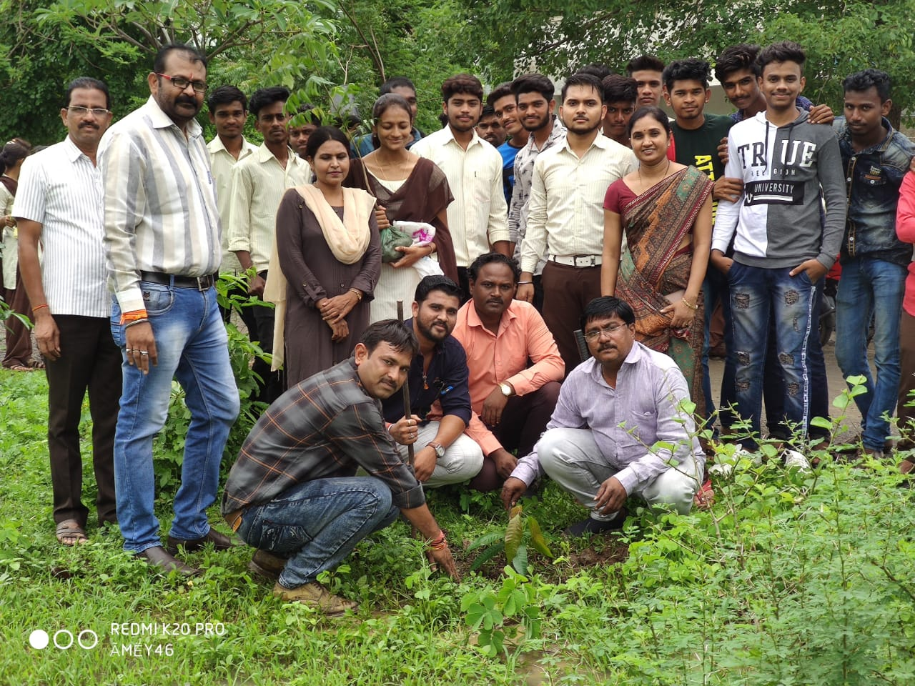

- Tree plantation program organized by department on the occasion of Independence Day.
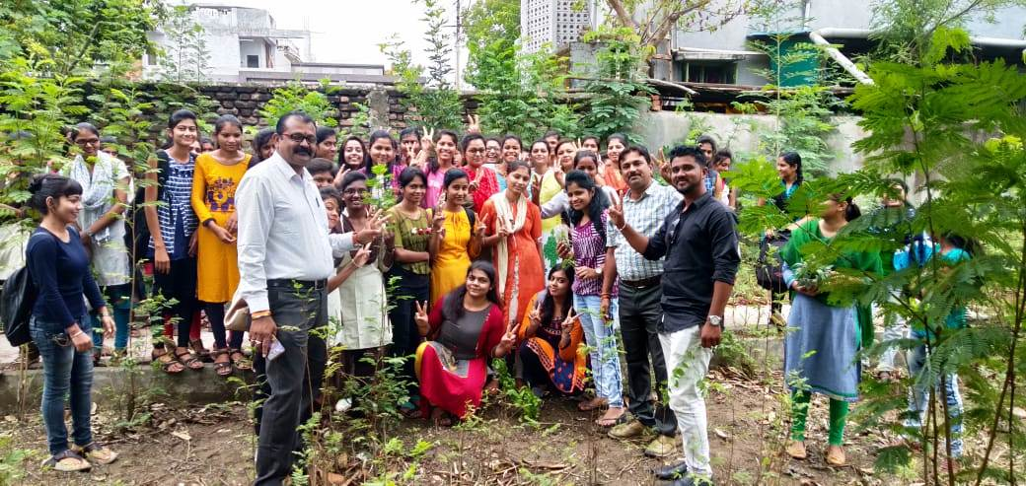
- Guest lecture on the occasion of wild life week (2017-18). Shree Nandakishor Raut Range Forest officer Maregaon present their knowledge on Wildlife Conservation. Dr. Abhay Patki Associate Professor (Zoology) S.P.M. Gillani College, Ghatanji delivered the speech on " Importance of Ecology".
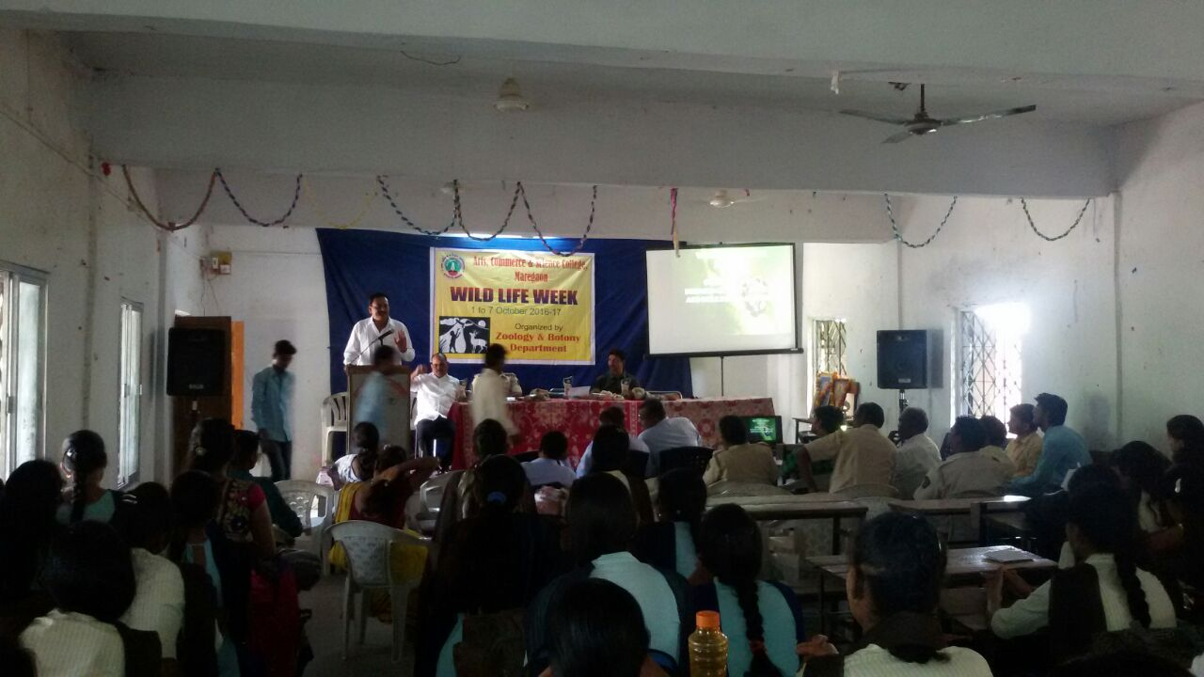
Guest Lecture on " Importance of Ecology"
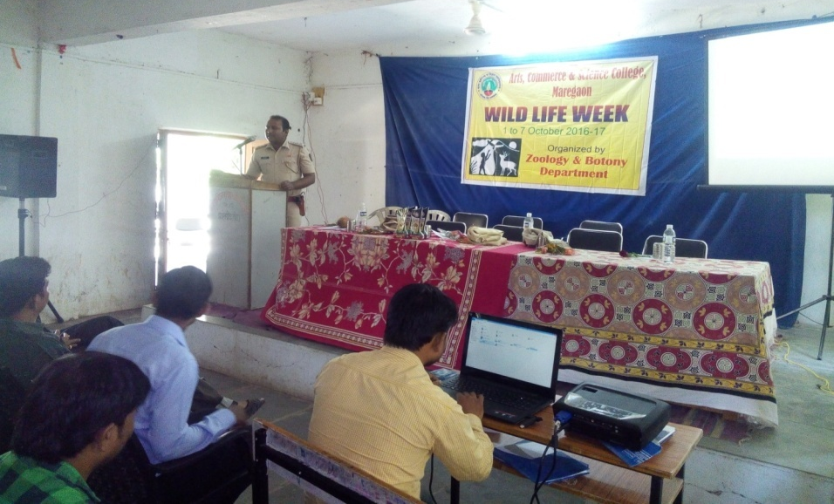
Guest lecture on "Importance of forest"
- Tree Plantation at Salebhatti
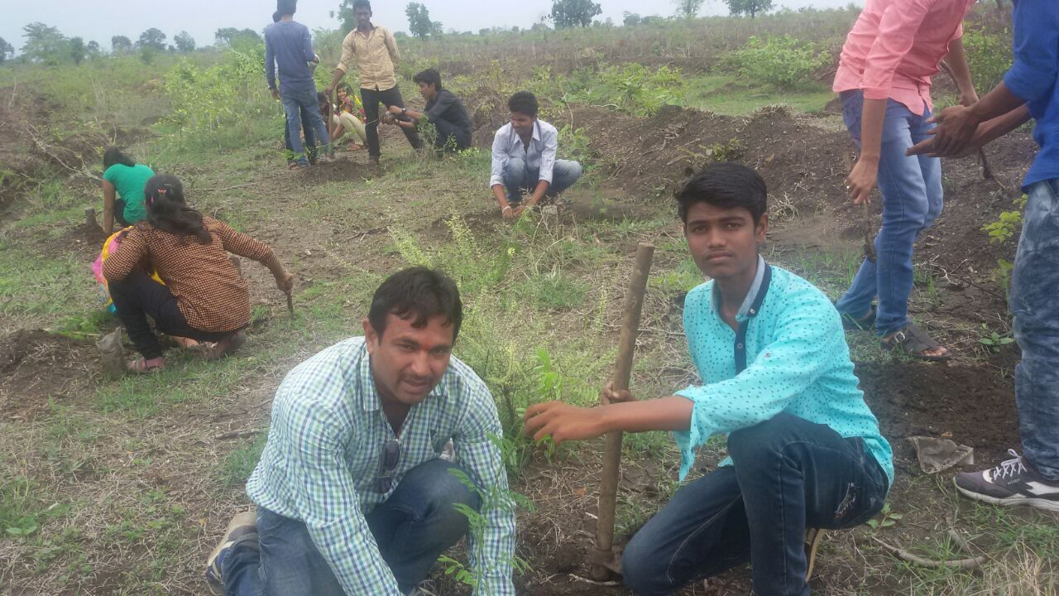
Wildlife Week celebration 2017-18
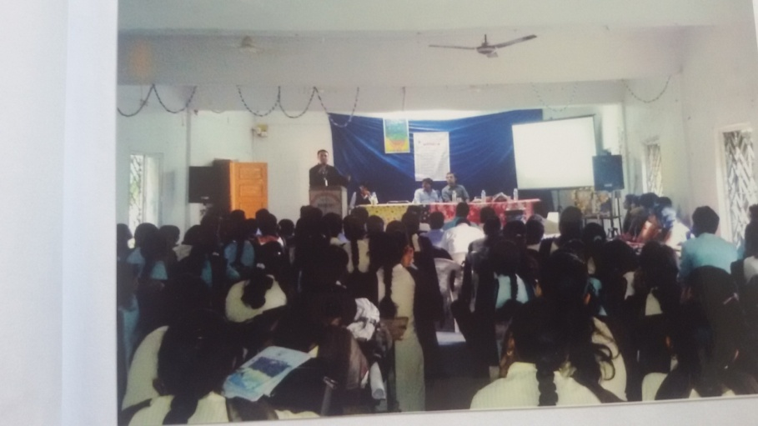
Dr. Gajendrasingh Pachlure delivered guest lecture on "Environmental issues"
Wild Life Week Celebration 2018-19
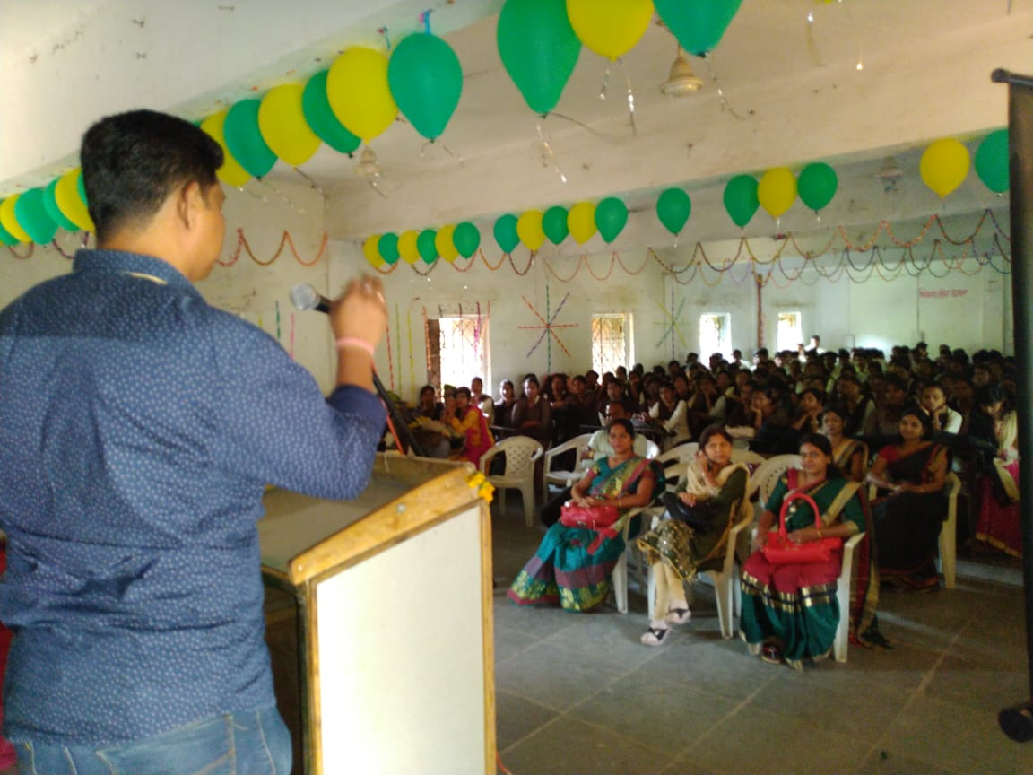
Dr. Chandrashekhar Kasar delivered guest lecture on " Ecosystem"
Wild Life Week Celebration 2018-19
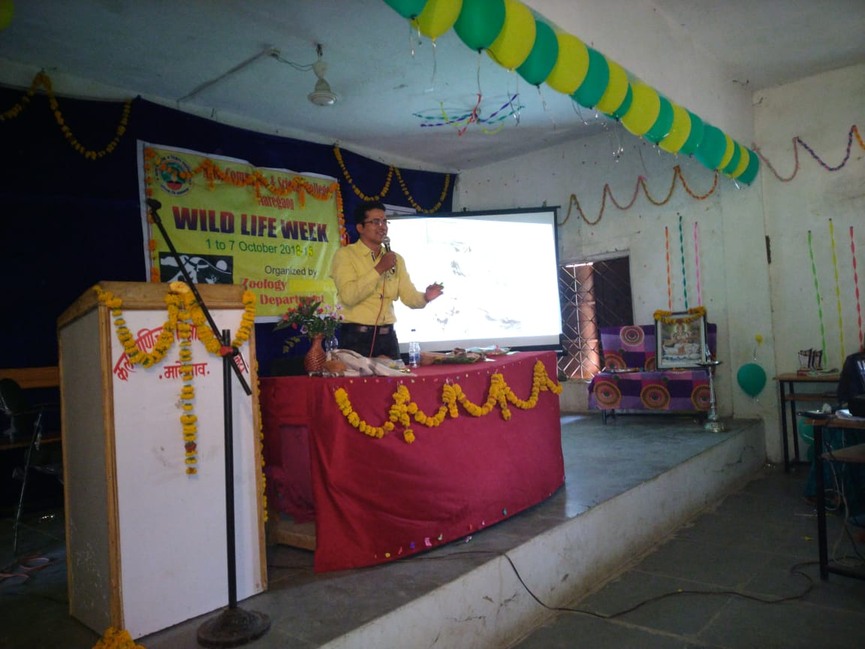
Dr. Pravin Joshi Delivered guest lecture on "Birds in Yavatmal "
Wild Life Week Celebration 2020-21
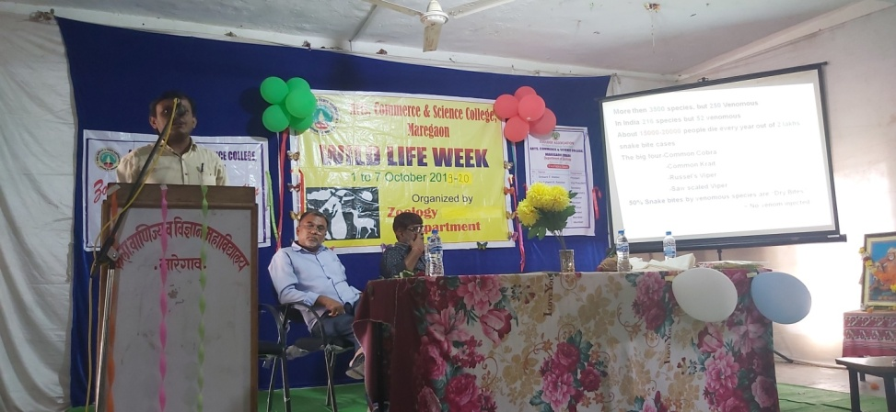
Dr. Paresh Patel delivered guest lecture on ‘Snakes in Wani”

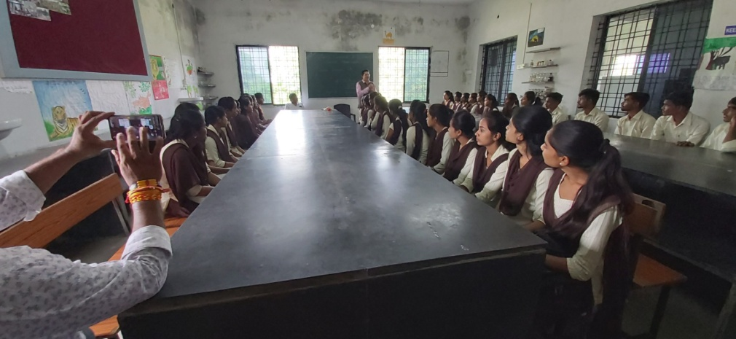
Dr. Pravin Joshi delivered guest lecture on “Diversity of Birds”

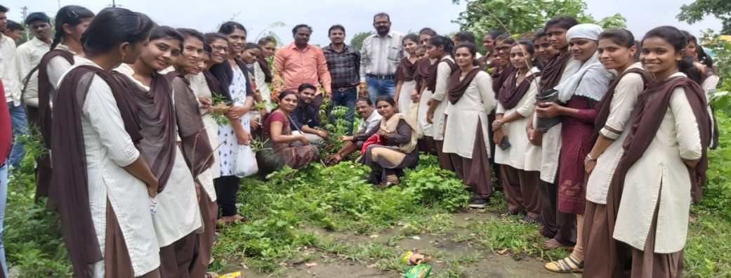
Tree Plantation at College Campus

Vadkeshwar Environmental Study Tour
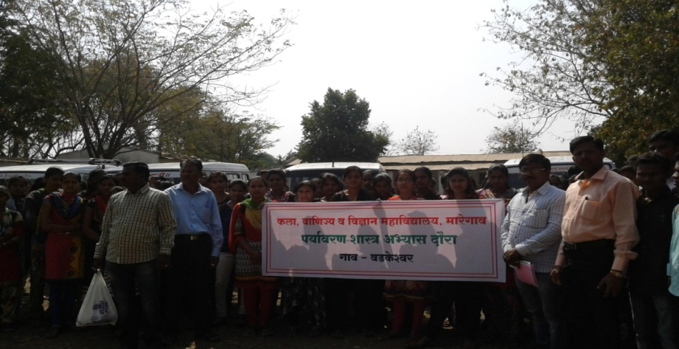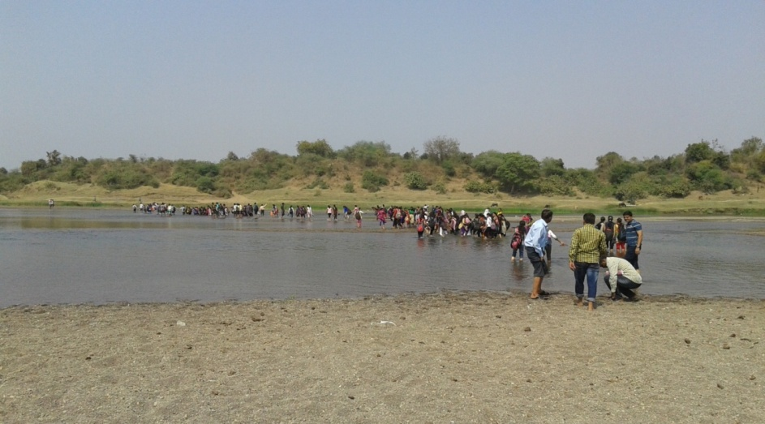
Vadkeshwar Environmental Study Tour
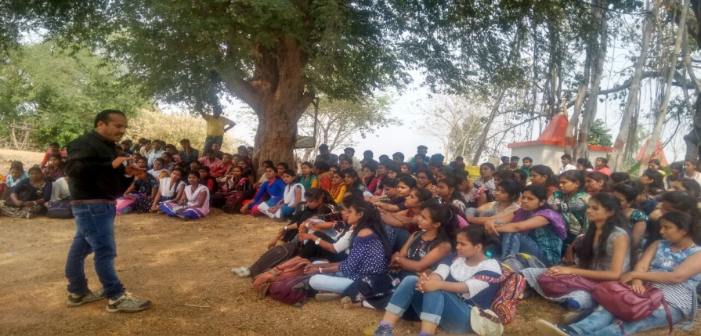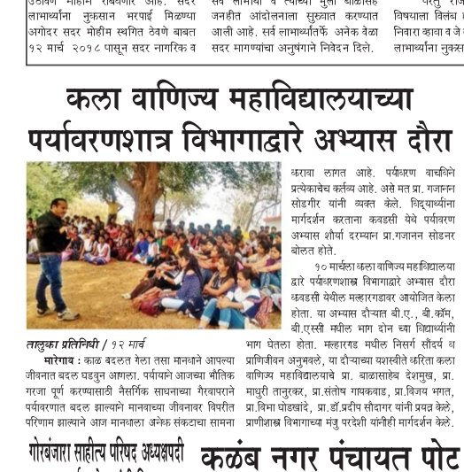Kawadshi Environmental Study Tour (2017-18)
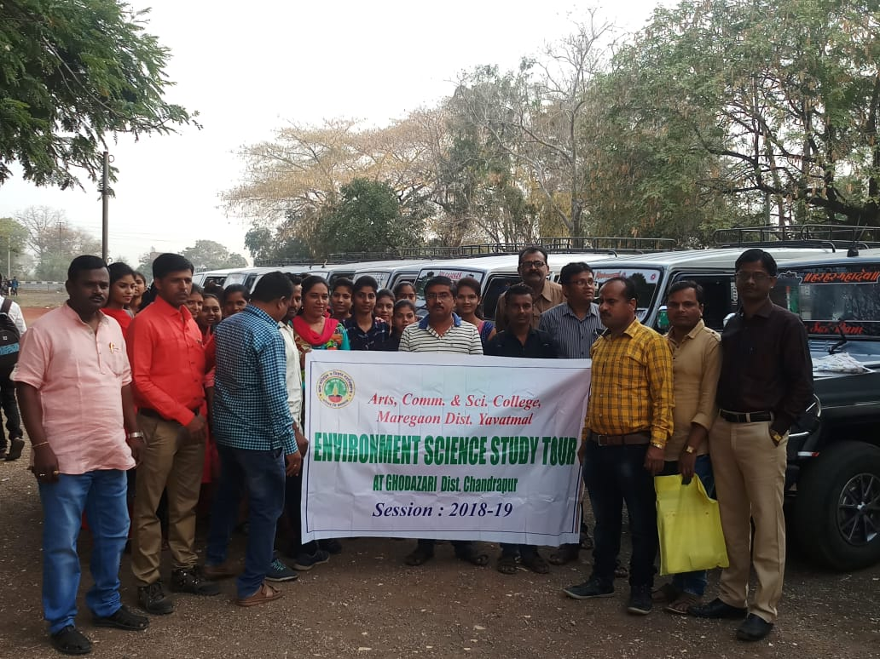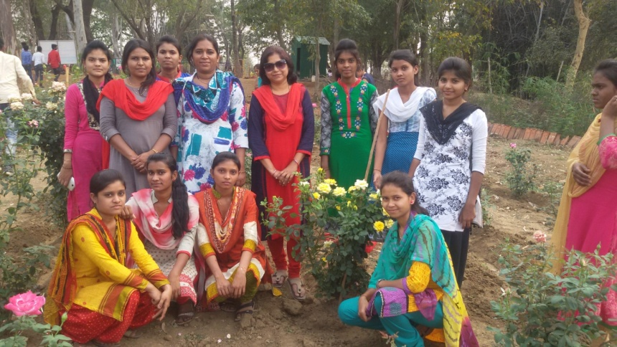
Environmental and Study Tour@ Ghodazari (2018-19)
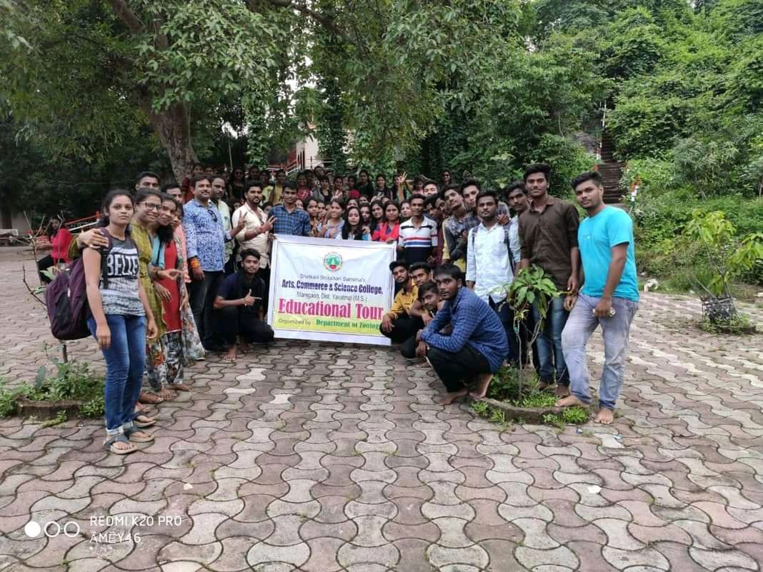
Educational Tour for field work at Asolamendha (2019-2020)

