Shetkari Shikshan Sanstha’s

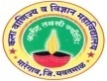

**ARTS, COMMERCE & SCIENCE COLLEGE, MAREGAON (ROAD)**

Dist. Yavatmal- 445 303 (M.S.) India

(Affiliated to Sant Gadge Baba Amravati University, Amravati)

NAAC Accredited at ‘B+’ grade with CGPA 2.51 (Cycle-I)

**3.2.1: Institution has created an ecosystem for innovations and has initiatives for creation and transfer of knowledge**

The college has created an Innovation and Entrepreneurship Development Cell, Student Development Cell, Career Development Cell, Student Welfare Committee, and Research committee to bring awareness about research, innovations and new technologies among the students, research scholars and teachers. The teachers and students are encouraged to take up research and developmental activities by utilizing the existing resources. Student development Cell organized skill development programs for students and information related to job opportunities, innovations and various opportunities of skill development are provided on their WhatsApp group. College has taken an initiative to encourage the teachers to pursue PhD and motivate them for research publications. Teachers are also encouraged to participate in various skill enhancement programs. The Research committee motivates the teachers to write research projects and submit them to various supporting agencies like DST, DBT, SERB, UGC, etc. The Research Committee conducts regular classes of PhD Course Work for registered PhD scholars in our college Research Centre and also helps to create research culture among the teachers, research scholars and students. College has MOUs and linkages with industries, national research laboratories and colleges.

Students are participated in Unnat Bharat Abhiyan, our college adopted five villages namely Kolgaon, Managrul, Wegaon, Nawargaon and Karanwadi in Maregaon Taluka. We have completed their village survey, household survey and sent the complete information and data to the Collector office, Yavatmal and to IIT Delhi, which implements the Unnat Bharat Abhiyan of the Government of India. During Survey, it was founding that villages have various problems and lack of facilities. To resolve these issues, our college registered for Unnat Bharat Abhiyan and selected under Unnat Bharat Abhiyan, a flagship program of Ministry of Human Resourse Development (MHRD) Government of India through a challenge mode application.  Project No. RP-03525G entitled “Installation of Auto Controlled Solar LED Street Lights" submitted under the Unnat Bharat Abhiyan 2.0 Program, has been approved by Others SEG and funded by the National Coordinating Institute UBA 2.0 (IIT Delhi) on 31 March, 2022.

Botanical garden in our college plays an important role in educating the students, villagers on the importance of eco-friendly gardening practices.  In our college botanical garden, we have developed eco-friendly native plant species and distributed to the villagers for plantation which can reduce its carbon footprint and promote biodiversity. The sustainable gardening practices, educating the peoples on the importance of environmental conservation.

**Botanical Garden:**

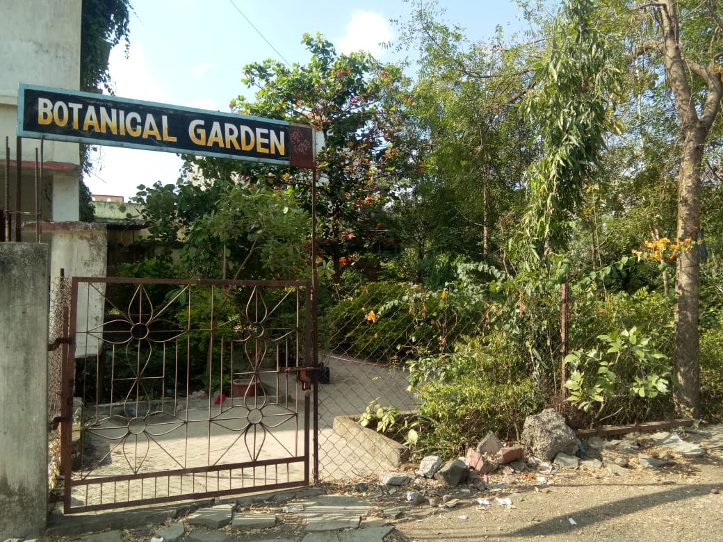

**Vermicompost project (**Earthworm for Vermicompost**):**

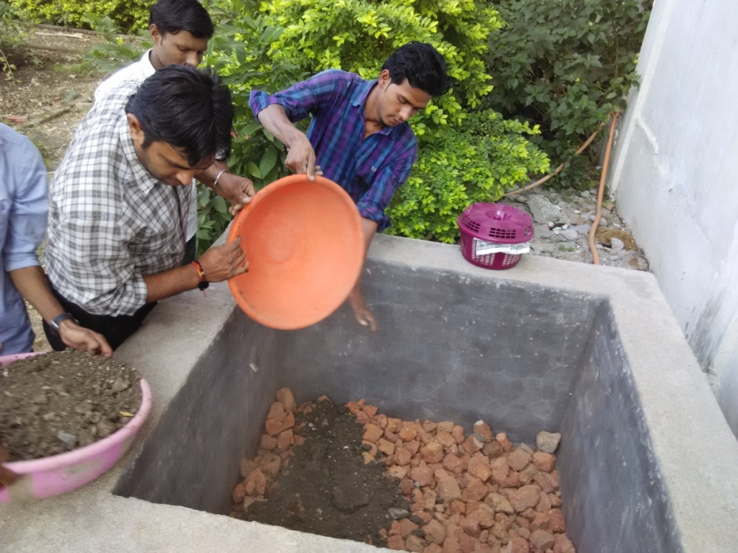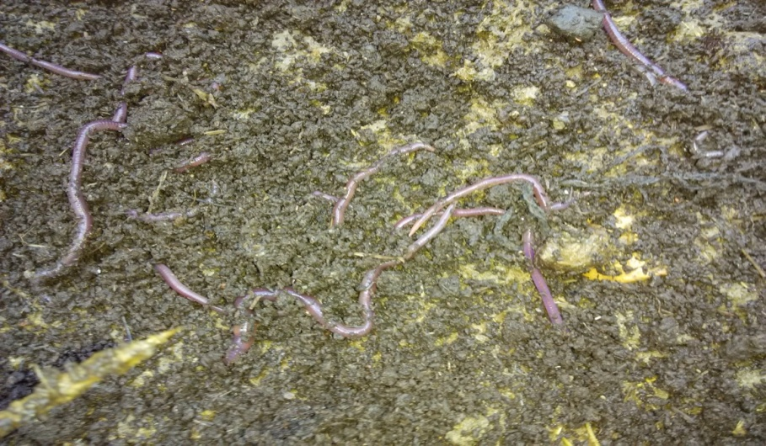

**Unnat Bharat Abhiyan:**

