Shetkari Shikshan Sanstha’s
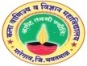
ARTS, COMMERCE & SCIENCE COLLEGE, MAREGAON (ROAD)
Dist. Yavatmal- 445 303 (M.S.) India
(Affiliated to Sant Gadge Baba Amravati University, Amravati)
NAAC Accredited at ‘B+’ grade with CGPA 2.51 (Cycle-I)

3.4.1: Extension activities are carried out in the neighborhood community, sensitizing students to social issues, for their holistic development, and impact thereof during the last five years.
The college provide an opportunity to the students to engage with local community for their holistic development. Students are learning about social issues by participating in number of activities and make a positive impact in the society. Our institution carried out number of extension activities for neighborhood community. Principal and the faculty members motivate to the students for various social activities which promote citizenship roles. Certificates of every social activity are given to the students. Our students are actively participated in the community service activities some of them are
Unnat Bharat Abhiyan
One month training program on “Cloth Bag” for poor, tribal and backward women’s in the society
Blood donation and health check-up camps
Awareness program on various health issues for society.
Awareness program on the use of new technologies of renewable energy through Unnat Bharat Abhiyan
Village survey and Household survey through Unnat Bharat Abhiyan
Awareness program on Gender issues
Rallies for AIDS awareness
Rallies for no use of Polythene
Rallies for celebrating pollution free, cracker-free Diwali and Social Festival
Field work and social activities through NSS camp in the Villages.
Tree plantation
Workshop on Skill development
Exhibition on novel and innovative ideas
Organization of Conferences, Workshops, Seminars and Guest lectures on socially important issues like malnutrition, women empowerment, gender issues & gender equality, etc.
The extension activities enhance social commitment together with personal, civic and academic learning of the students. The students are interacting with the eminent experts, scientists through guest lectures and seminars. These interactions inspire the students to initiate the interest in basic research. The NSS and Sports activities inculcate the values of brotherhood, national integrity development of leadership and spirit of team work among the students
One month training program on “Cloth Bag” for poor, tribal and backward women’s in the society during 03 January, 2022 to 07 February, 2022

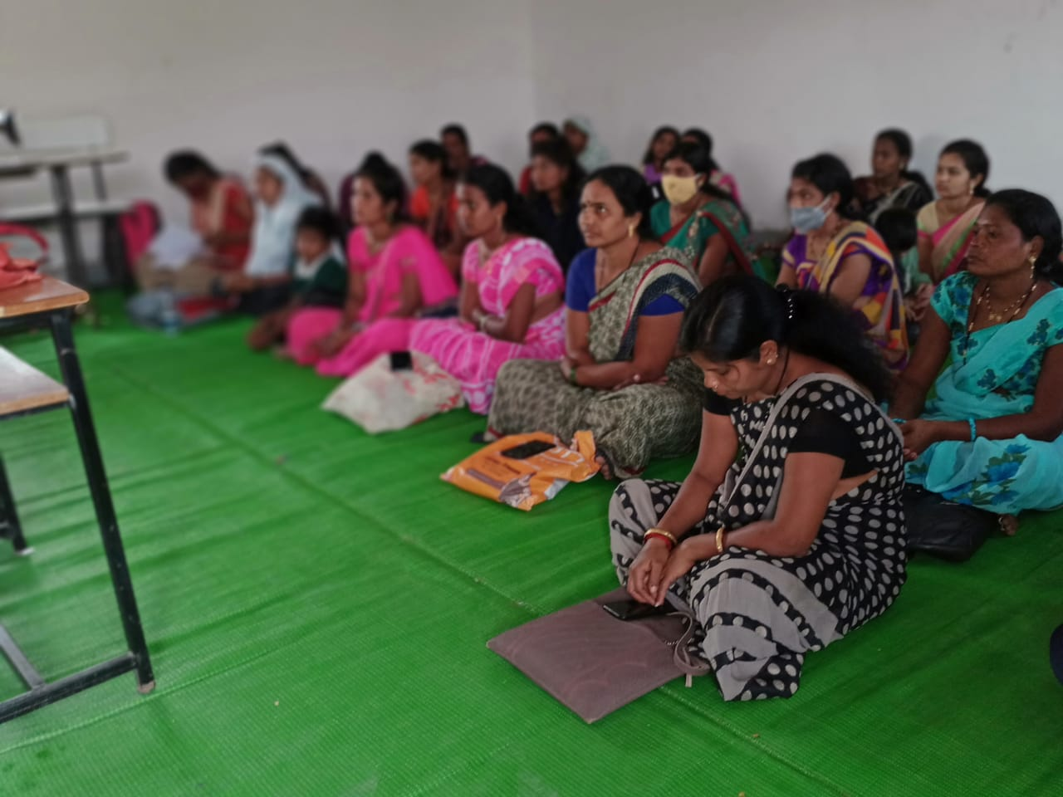
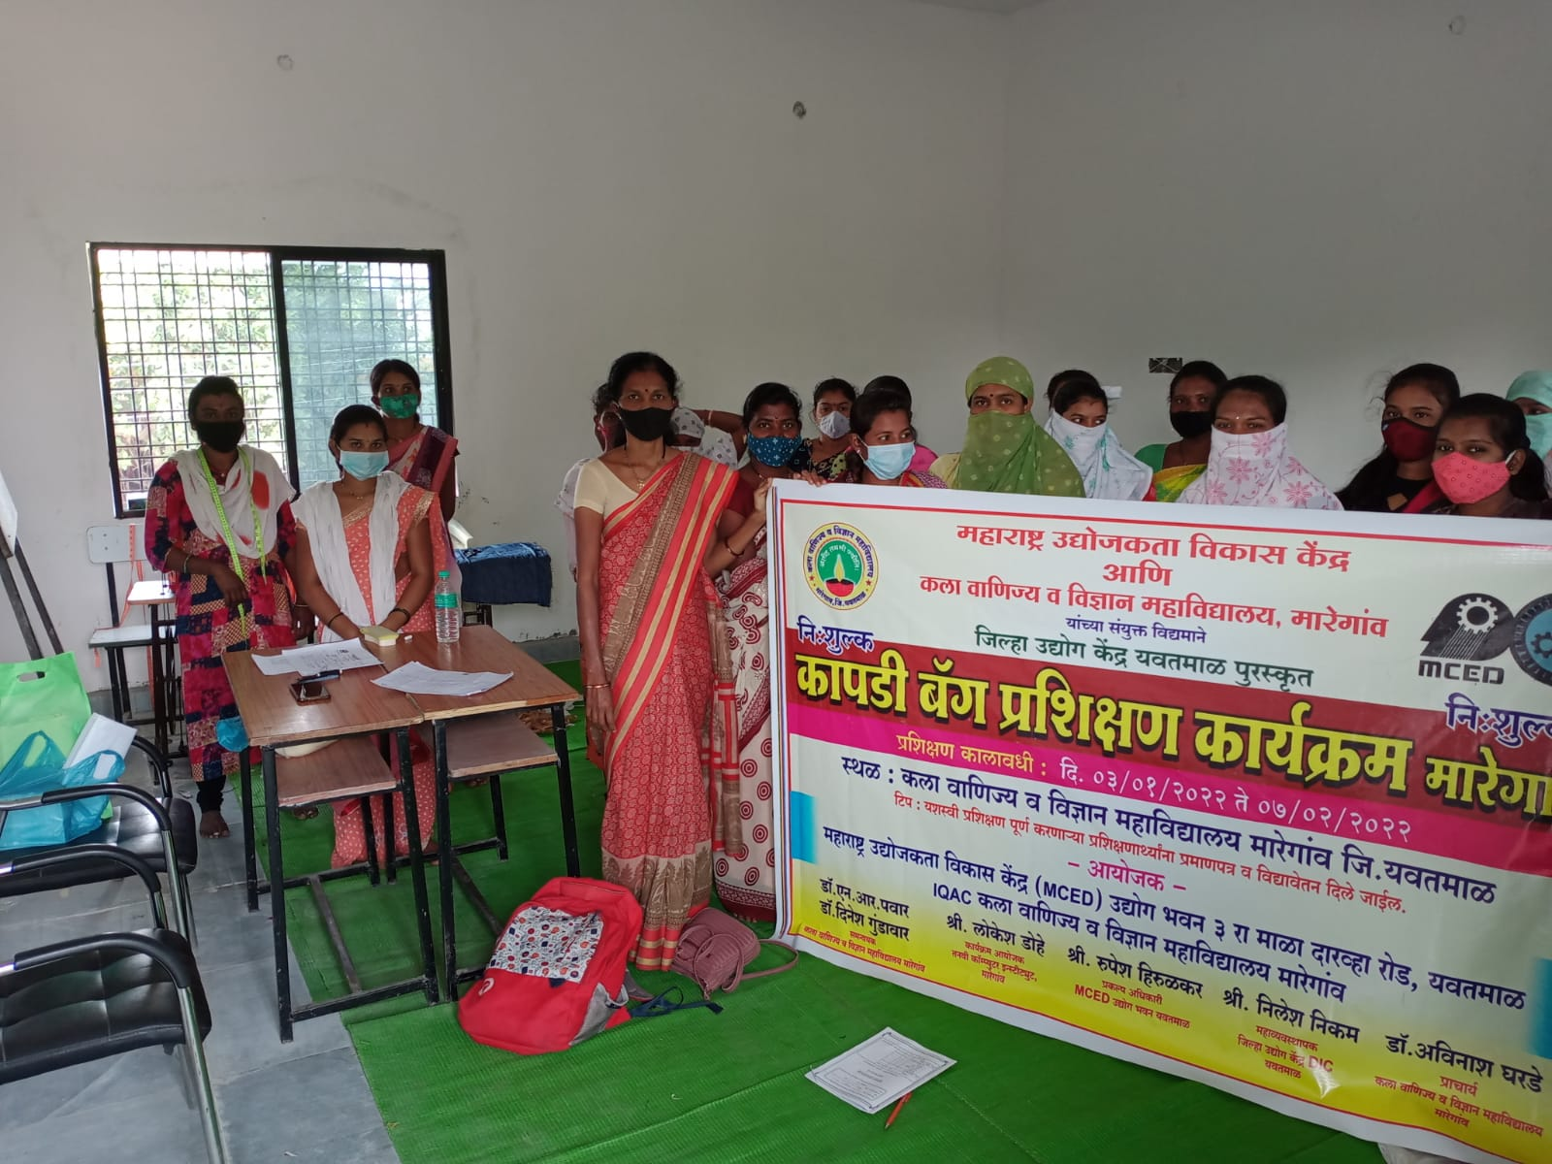
Skill Development Program during 04-05 February, 2020
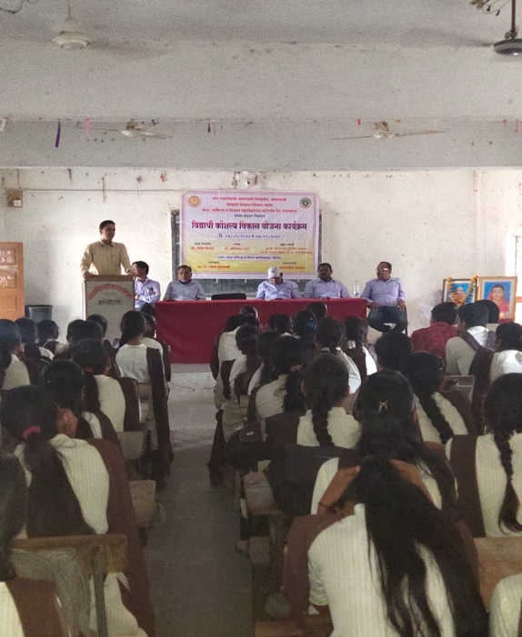
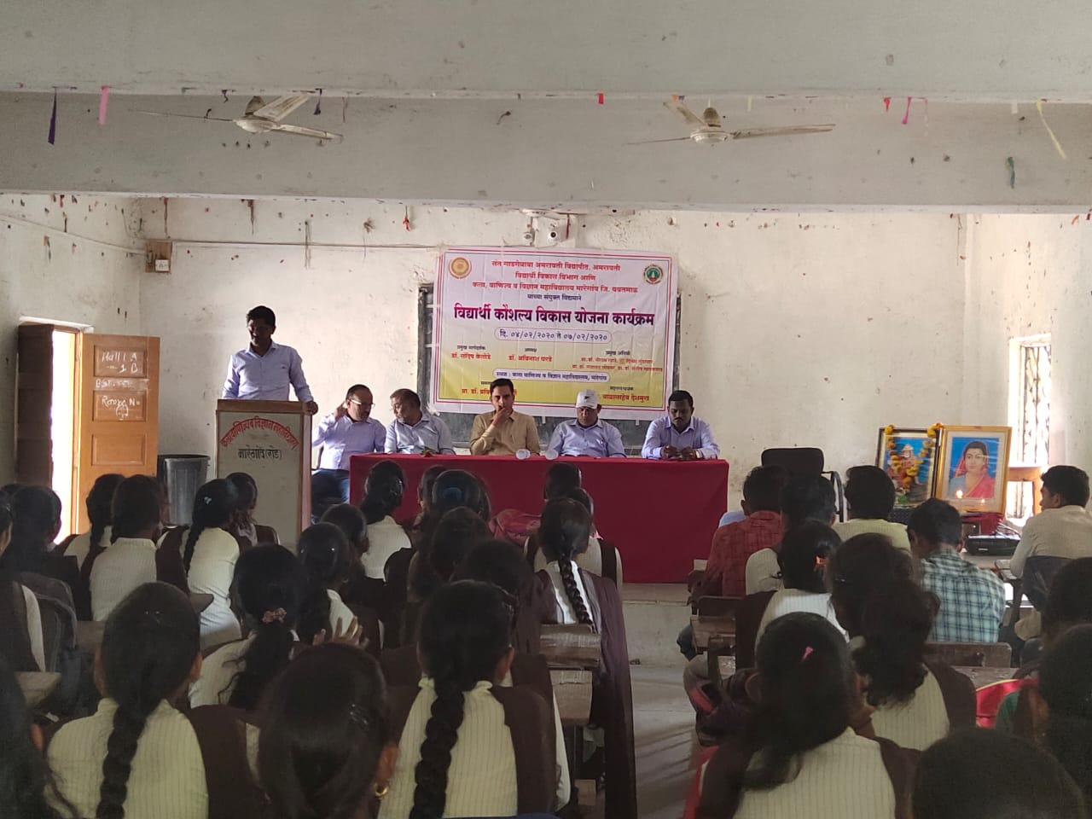
Various activities through NSS Camp at Chinchala during 27 January, 2019 to 03 February, 2019
