Shetkari Shikshan Sanstha’s
ARTS, COMMERCE & SCIENCE COLLEGE, MAREGAON (ROAD)
Dist. Yavatmal- 445 303 (M.S.) India
(Affiliated to Sant Gadge Baba Amravati University, Amravati)
NAAC Accredited at ‘B+’ grade with CGPA 2.51 (Cycle-I)

3.4.2: Awards and recognitions received for extension activities from government / government recognised bodies
Name of the activity | Name of the Award/ recognition for Institution | Name of the Awarding government/ government recognised bodies | Year of award
Recognition as Ph.D. Supervisor to Dr. D. A. Gundawar | Recognition as Ph.D Supervisor in the subject English | Gondwana university, Gadchiroli | September, 2017
Recognition as Ph.D. Supervisor to Dr. S. R. Kelode | Recognition as Ph.D Supervisor in the subject Chemistry | Amravati university, Amravati | March, 2019
Dr. P. P. Kulkarni awarded Ph. D. degree in Commerce | S. G. B., Amravati University, Amravati | S. G. B., Amravati University, Amravati | June, 2019
Dr. G. L. Sodnar awarded Ph. D. degree in History | S. R. T. M. University, Nanded | S. R. T. M. University, Nanded | July, 2019
Dr. S.B. Gaikwad awarded Ph. D. degree in Commerce | Dr. B.A.M.U. Aurangabad | Dr. B.A.M.U. Aurangabad | November, 2019
Best Paper Award to Dr. N. R. Pawar | Best Paper Award | International Conference on Ultrasonic and Materials Science and Advanced Technology organized by Veer Bahadur Sing Purvanchal University, Jaunpur | November, 2019
Maharashtra Gaurav Puraskar to Dr. N. R. Pawar | Maharashtra Gaurav Puraskar | Government of Maharashtra | January, 2020
Recognation as Ph.D. Supervisor to Dr. D. A. Gundawar | Recognition as Ph.D. Supervisor in the subject English | S. G. B., Amravati University, Amravati | June, 2020
Dr. D. A. Gundawar, Review Panel member | As Reviewer | International Journal of English and Literature | May, 2021
Dr. D. A. Gundawar, Review Panel member | As Reviewer | International Journal of English and Literature | May, 2021
Research Centre Recognition | Recognition of Research Centre in the Subject English | S. G. B., Amravati University, Amravati | May, 2022
Recognition as Ph.D. Supervisor to Dr. G. L.Sodnar | Recognition of Ph. D. Supervisor in the subject History | S. G. B., Amravati University, Amravati | June, 2020
Research Centre Recognition | Recognition of Research Centre in the Subject Chemistry | S. G. B., Amravati University, Amravati | 2021
Research Centre Recognation | Recognition of Research Centre in the Subject History | S. G. B., Amravati University, Amravati | 2021
Recognition as Ph.D. Supervisor to Dr. S. K. Khade | Recognition of Supervisor for Ph. D. in the subject Sociology | S. G. B., Amravati University, Amravati | 2021
Research Centre Recognition | Recognition of Research Centre in the Subject Sociology | S. G. B., Amravati University, Amravati | June, 2021
Recognition as Ph.D. Supervisor to Dr. P. P. Kulkarni | Recognition as Ph. D. Supervisor in the subject Commerce | S. G. B., Amravati University, Amravati | June, 2020
Dr. P. P. Kulkarni appointed as Member of Editoriol Board | Member of Editorial Board | Dnyanpath Publication, Amravati | November, 2021
Research Centre Recognition | Recognition of Research Centre in the Subject Commerce | S. G. B., Amravati University, Amravati | June, 2021
Recognition as Ph.D. Supervisor to Dr. S. B. Gaikwad | Recognition of Supervisor for Ph. D. In the subject Commerce | S. G. B., Amravati University, Amravati | June, 2021
Recognition as Ph.D. Supervisor to Dr. V. N. Chavhan | Recognition of Supervisor for Ph. D. In the subject Botany | S. G. B., Amravati University, Amravati | September, 2021
Recognition as Ph.D. Supervisor to Dr. N. R. Pawar | Recognition of Supervisor for Ph. D. In the subject Physics | S. G. B., Amravati University, Amravati | September, 2021
Dr. P. P. Kulkarni awarded | Excellence, Sprirt and Dedication in writing the book B.Com-I Sem-I & II | Dnyanpath Publication, Amravati | 2021-2022
Recognition as Joint Secretary to Dr N R Pawar | Recognition as Joint Secretrary | Ultrasonics Society of India, CSIR, NPL, Pusa, New Delhi | May, 2022
Research Centre Recognition | Recognition of Research Centre in the Subject English | S. G. B., Amravati University, Amravati | May, 2022
Dr. N. R. Pawar appointed as Member of Editorial Board | Member of Editorial Board | International Journal Scientific Research in Science and Technology | 2022
Research Centre Recognition | Recognition of Research Centre in the Subject of Botany | S. G. B., Amravati University, Amravati | May, 2022
Research Centre Recognition | Recognition of Research Centre in the Subject Physics | S. G. B., Amravati University, Amravati | May, 2022
Recognition as Ph.D. Supervisor to Dr. R. R. Chaware | Recognition of Supervisor for Ph. D. in the subject Marathi | S. G. B., Amravati University, Amravati | May, 2022
Research Centre Recognition | Recognition of Research Centre in the Subject Marathi | S. G. B., Amravati University, Amravati | December, 2022
Felicitation of Dr. P. P. Kulkarni | For the award of Ph.D. Degree | Janta pathsantha Chandrapur | September, 2022
Recognition as Ph.D. Supervisor to Dr. M. K. Tanurkar | Recognition of Research Centre in the Subject Commerce | S. G. B., Amravati University, Amravati | May, 2022

Dr. D. A. Gundawar - Recognized as Ph D Supervisor Gondwana University, Gadchiroli Notification No.GUG/Ph D Sup Rec/675/2017
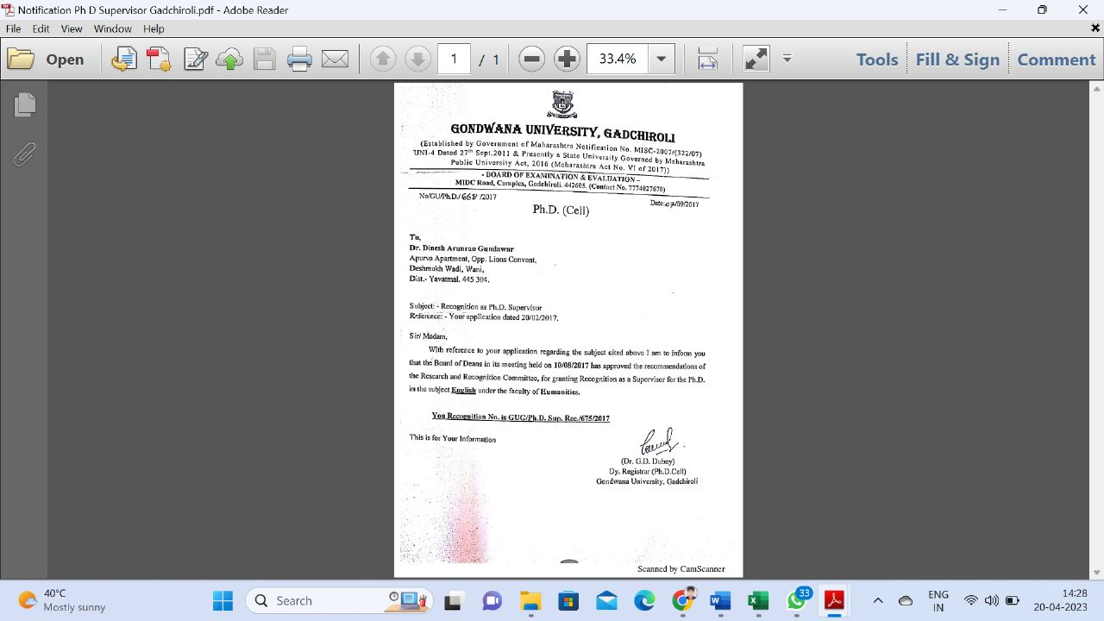

Recognized as Ph D Supervisor SGB Amravati University, Amravati Notification No. SGBAU/Ph D Sup Rec/43/2020 Dated-04/06/2020

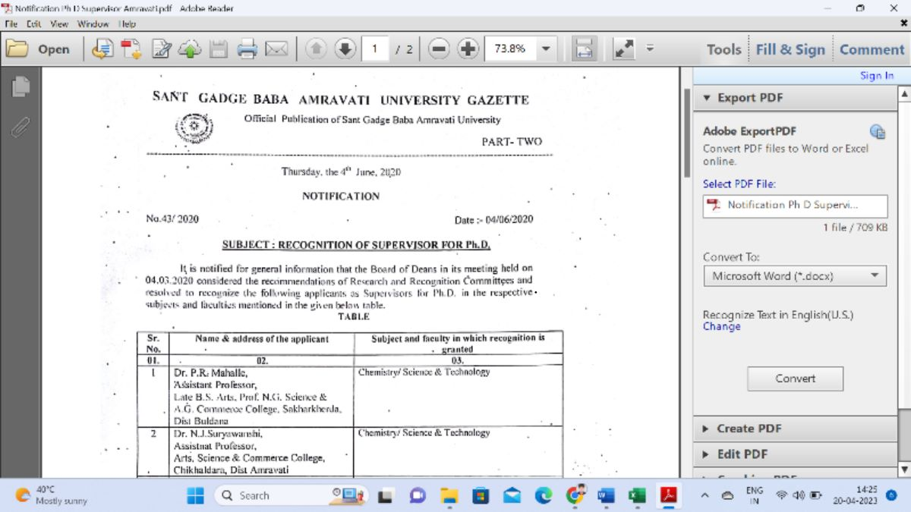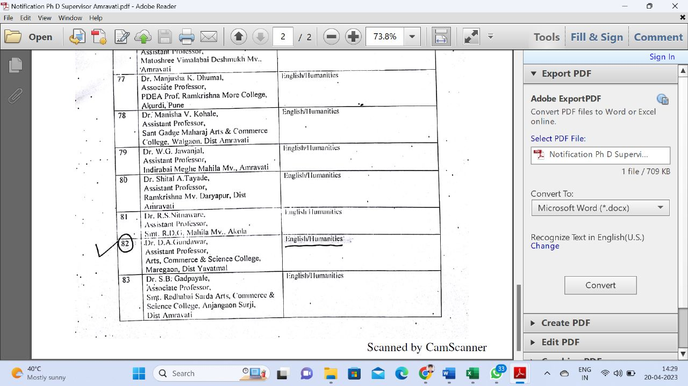

Review Panel Member-Academic Journal-International Journal of English & Literature
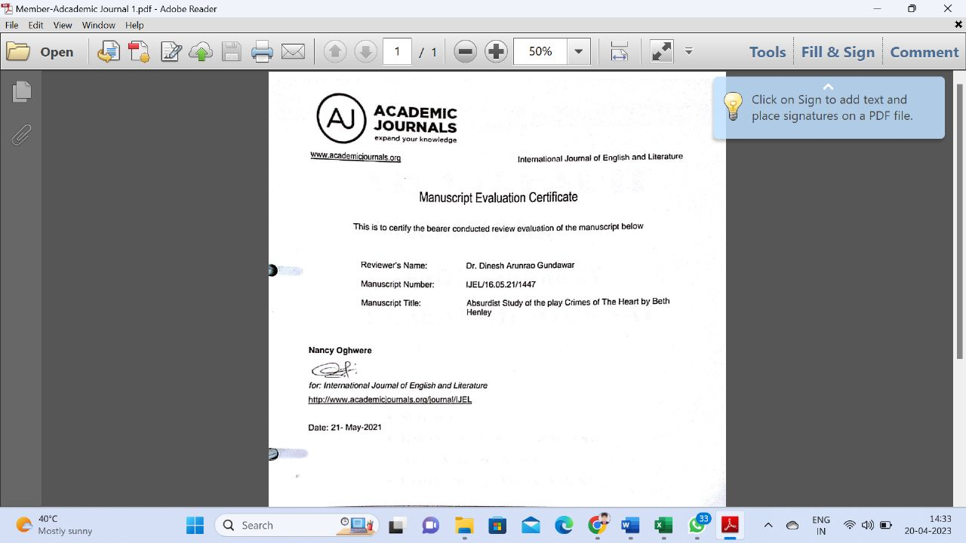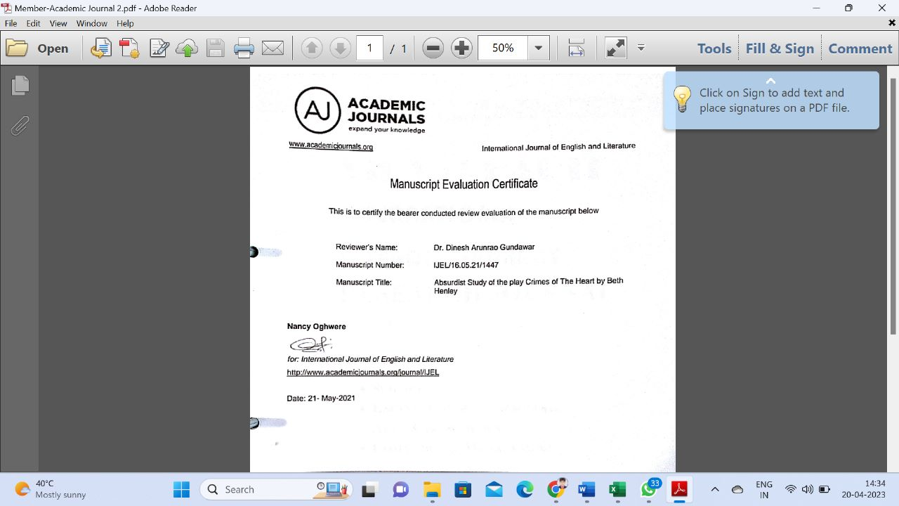

Recognized Research Centre in the subject English SGB Amravati University, Amravati Notification No. SGBAU/Ph D Sup Rec/48/2022 Dated- 19 /05 /2022

Dr. G. L. Sodnar – awarded Ph. D. In History
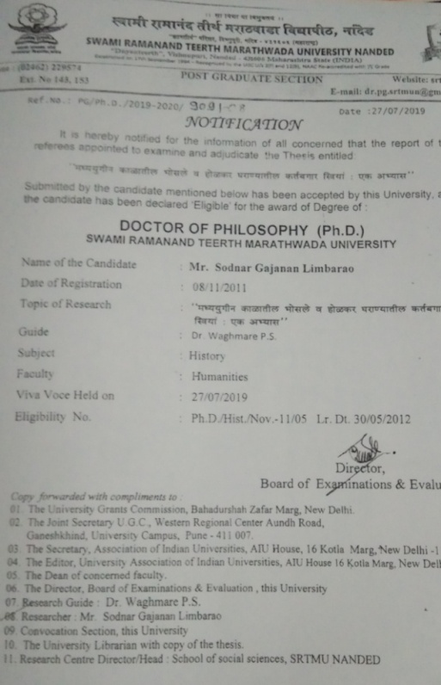

Recognized as Ph D Supervisor SGB Amravati University, Amravati Notification No. SGBAU/Ph D Sup Rec/43/2020 Dated- 04 /06 /2020

Recognized Research Centre in the Subject of History
Dr. S. K. Khade - Recognize PhD Supervisor S.G.B.A.U Notification No. 58/2021 Dated 21/06/2021
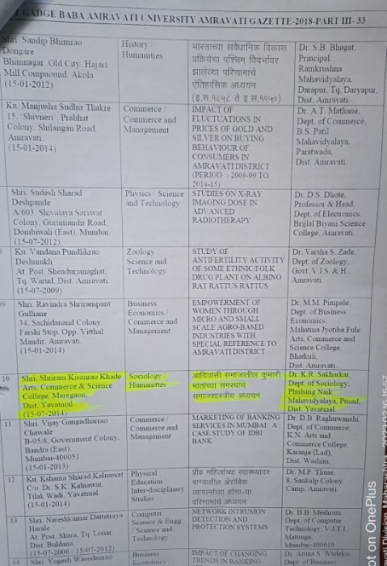
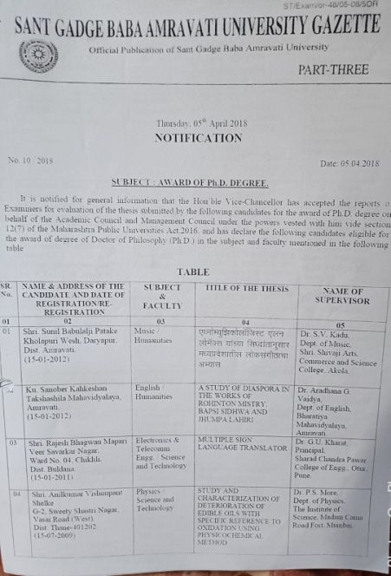

- Recognized Research Centre in the subject Sociology SGB Amravati University, Amravati Notification No. SGBAU/Ph D Sup Rec/48/2022 Dated- 19 /05 /2022

Dr. P. P. Kulkarni – awarded Ph. D. In Commerce

Excellence, Sprirt and Dedication in writing the book B.Com-I Sem-I
Excellence, Sprirt and Dedication in writing the book B.Com-I Sem-II
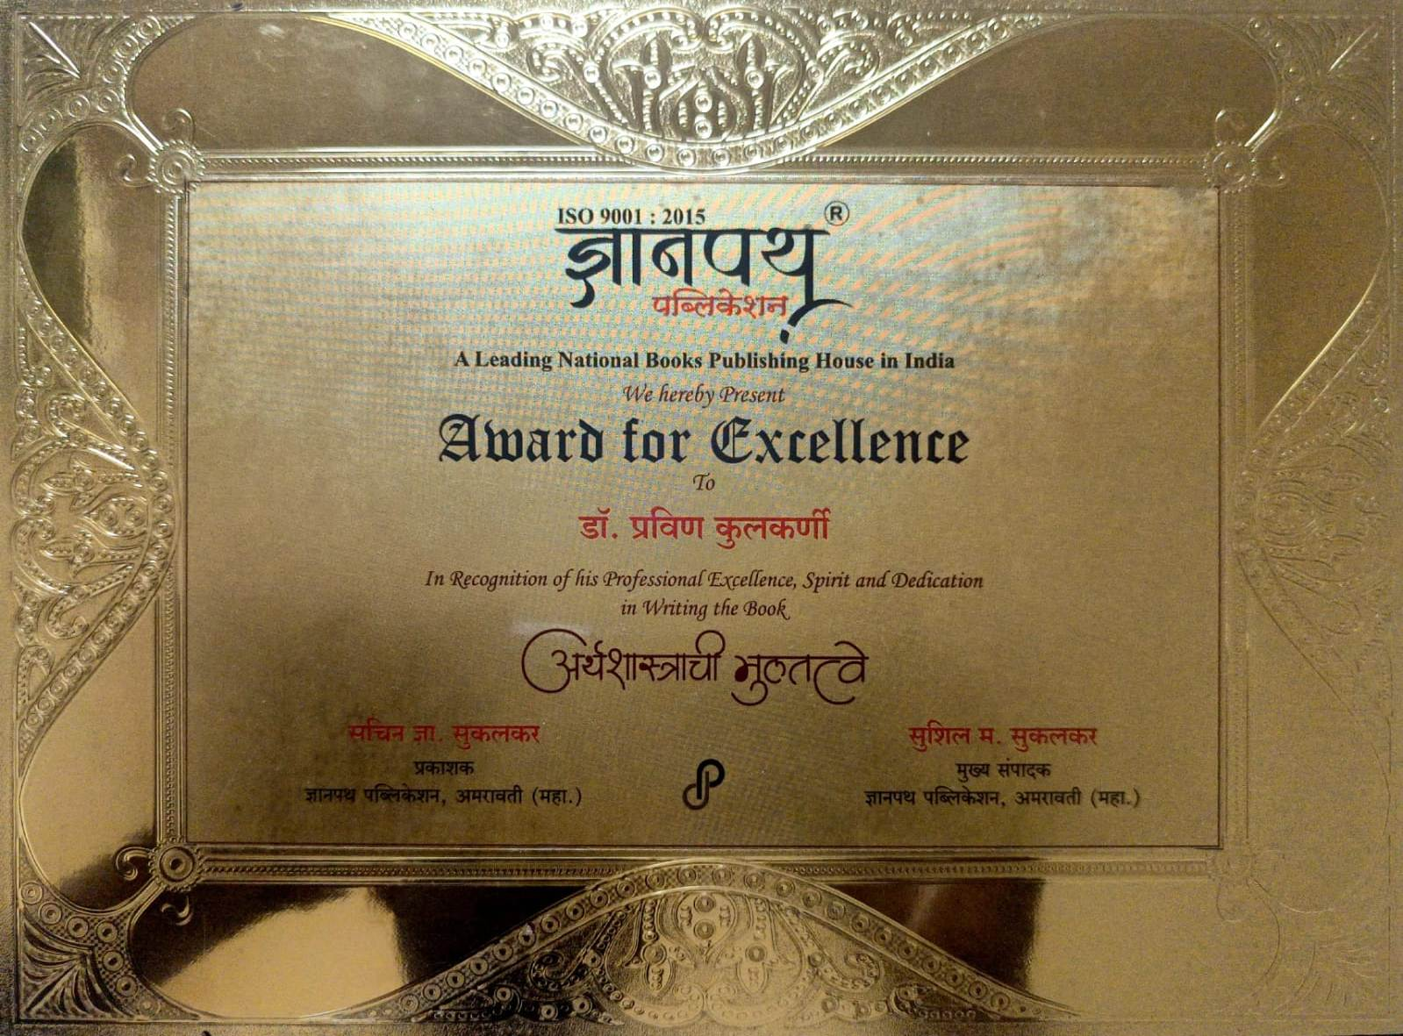

Janta pathsantha Chandrapur
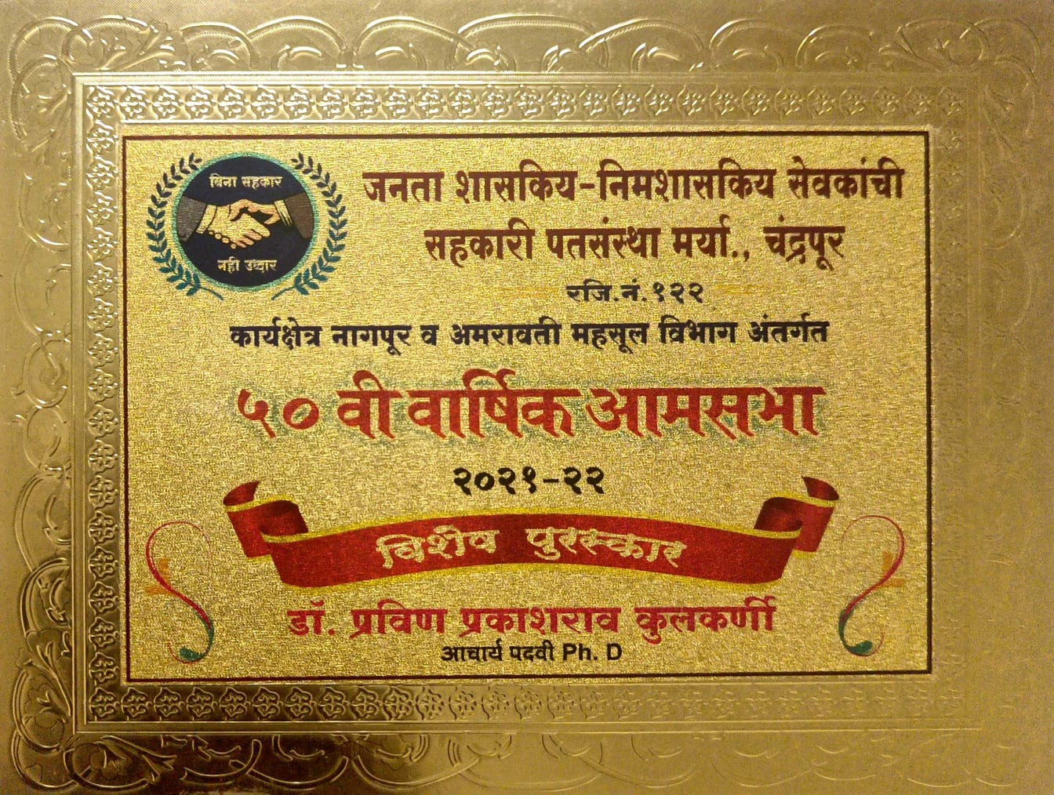
- Recognized as Ph D Supervisor SGB Amravati University, Amravati Notification No. SGBAU/Ph D Sup Rec/43/2020 Dated- 04 /06 /2020
Dr. P. P. Kulkarni appointed as member of Editorial Board by Dnyanpath Publication, Amravati.
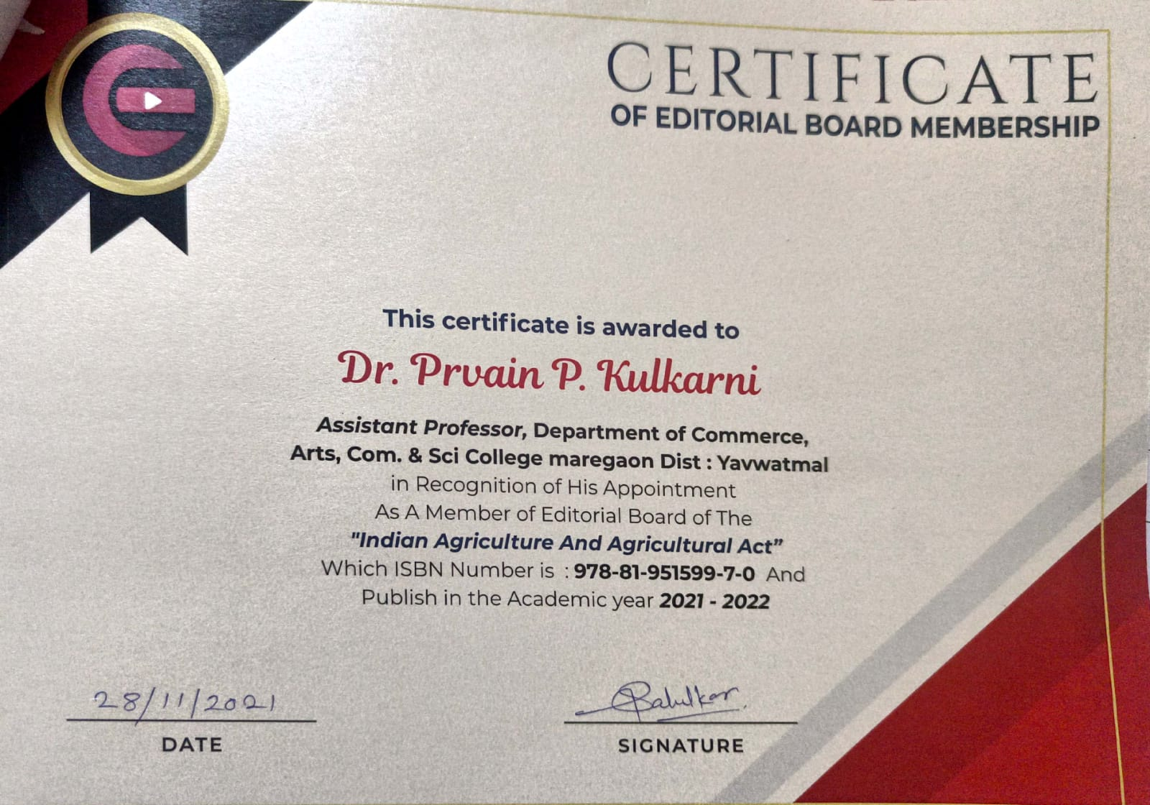
Recognised Research Centre in the Subject of Commerce
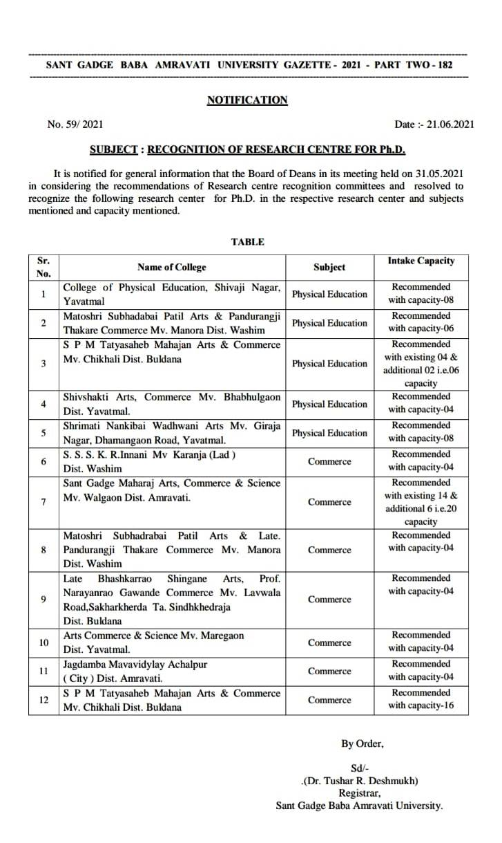
Dr. S. B. Gaikwad - awarded Ph. D. In Commerce

- Recognized as Ph D Supervisor SGB Amravati University,Amravati Notification No. SGBAU/Ph D Sup Rec/ /2021 Dated- 21 /06 /2021

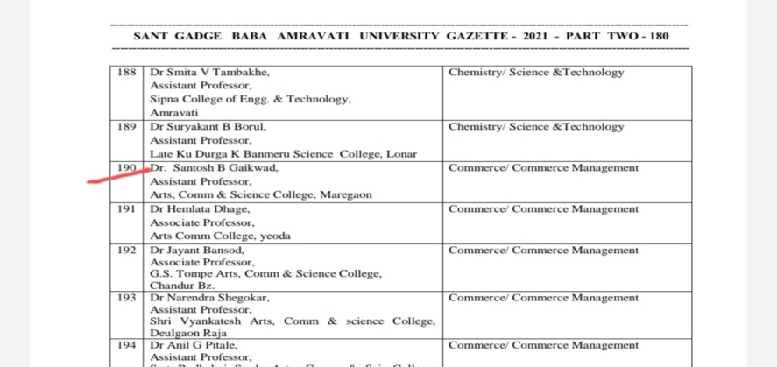

Dr. V. N. Chavhan - Recognition of Supervisor for Ph. D. In Botany
- Recognized Research Centre in the subject Botany SGB Amravati University, Amravati Notification No. SGBAU/Ph D Sup Rec/48/2022 Dated- 19 /05 /2022
Dr. N. R. Pawar - Recognition of Supervisor for Ph. D. In Physics

- Recognized Research Centre in the subject Physics SGB Amravati University, Amravati Notification No. SGBAU/Ph D Sup Rec/48/2022 Dated- 19 /05 /2022

